Module 1: Cloud Concepts Overview

Section 1: Introduction to cloud

computing

After completing this module, you should be able to:

• Define different types of cloud computing

• Describe six advantages of cloud computing

• Recognize the main AWS service categories and core services

• Review the AWS Cloud Adoption Framework (AWS CAF)

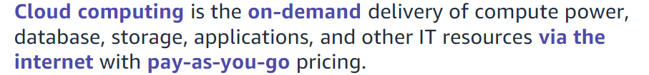

Cloud computing enables you to stop thinking of your infrastructure as hardware, and instead think of (and use) it as software.

With a hardware solution, you must ask if there is enough resource capacity or sufficient storage to meet your needs, and you provision capacity by guessing theoretical maximum peaks. If you don’t meet your projected maximum peak, then you pay for expensive resources that stay idle. If you exceed your projected maximum peak, then you don’t have sufficient capacity to meet your needs. And if your needs change, then you must spend the time, effort, and money required to implement a new solution.

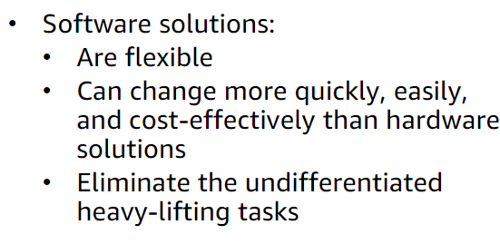

Cloud computing helps developers and IT departments avoid undifferentiated work like procurement, maintenance, and capacity planning, thus enabling them to focus on what matters most.

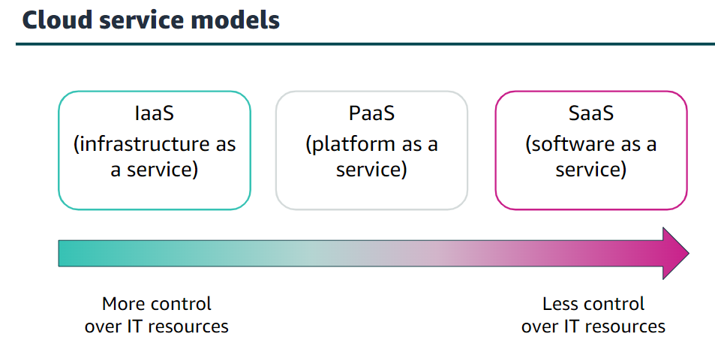

* Infrastructure as a service (IaaS): Services in this category are the basic building blocks for cloud IT and typically provide you with access to networking features, computers (virtual or on dedicated hardware), and data storage space.
* Platform as a service (PaaS): Services in this category reduce the need for you to manage the underlying infrastructure (usually hardware and operating systems) and enable you to focus on the deployment and management of your applications.
* Software as a service (SaaS): Services in this category provide you with a completed product that the service provider runs and manages. In most cases, software as a service refers to end-user applications. With a SaaS offering, you do not have to think about how the service is maintained or how the underlying infrastructure is managed   
    
  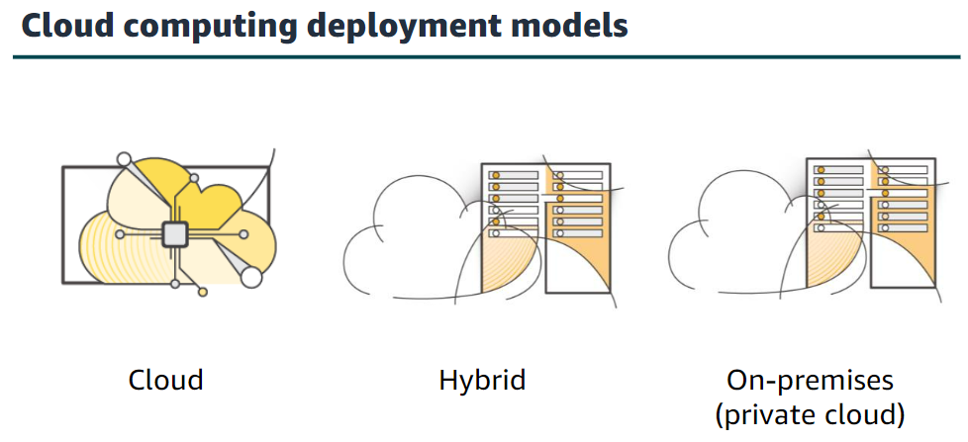
* Cloud: A cloud-based application is fully deployed in the cloud, and all parts of the application run in the cloud. Applications in the cloud have either been created in the cloud or have been migrated from an existing infrastructure to take advantage of the benefits of cloud computing
* Hybrid: The most common method of hybrid deployment is between the cloud and existing on-premises infrastructure. This model enables an organization to extend and grow their infrastructure into the cloud while connecting cloud resources to internal systems.
* On-premises: Deploying resources on-premises, using virtualization and resource management tools, is sometimes called private cloud. While on-premises deployment does not provide many of the benefits of cloud computing, it is sometimes sought for its ability to provide dedicated resources.

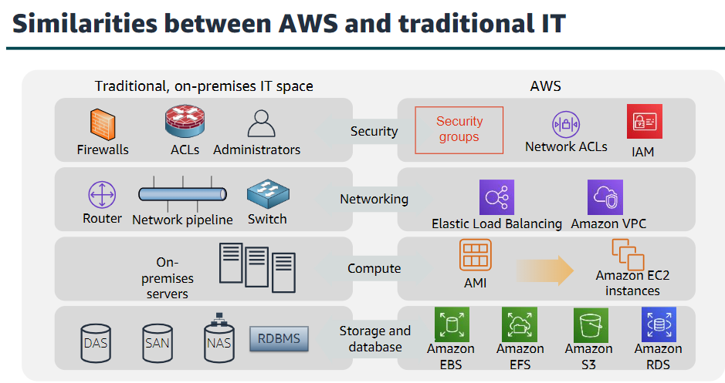

There are many similarities between AWS and the traditional, on-premises IT space:

* AWS security groups, network access control lists (network ACLs), and AWS Identity and Access Management (IAM) are similar to firewalls, access control lists (ACLs), and administrators.
* Elastic Load Balancing and Amazon Virtual Private Cloud (Amazon VPC) are similar to routers, network pipelines, and switches.
* Amazon Machine Images (AMIs) and Amazon Elastic Compute Cloud (Amazon EC2) instances are similar to on-premises servers.
* Amazon Elastic Block Store (Amazon EBS), Amazon Elastic File System (Amazon EFS), Amazon Simple Storage Service (Amazon S3), and Amazon Relational Database Service (Amazon RDS) are similar to direct attached storage (DAS), storage area networks (SAN), network attached storage (NAS), and a relational database management service (RDBMS).

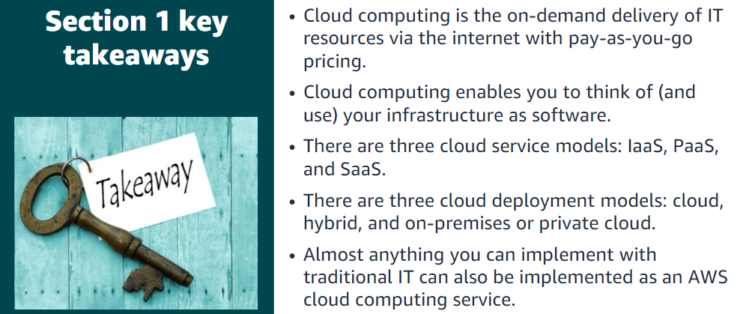

Section 2: Advantages of cloud

computing

Advantage #1—Trade capital expense for variable expense: Capital expenses (capex) are funds that a company uses to acquire, upgrade, and maintain physical assets such as property, industrial buildings, or equipment.

By contrast, a variable expense is an expense that the person who bears the cost can easily alter or avoid. Instead of investing heavily in data centers and servers before you know how you will use them, you can pay only when you consume resources and pay only for the amount you consume. Thus, you save money on technology.

Advantage #2—Benefit from massive economies of scale: By using cloud computing, you can achieve a lower variable cost than you can get on your own. Because usage from hundreds of thousands of customers is aggregated in the cloud, providers such as AWS can achieve higher economies of scale, which translates into lower pay-as-you-go prices.

Advantage #3—Stop guessing capacity: Eliminate guessing about your infrastructure capacity needs. When you make a capacity decision before you deploy an application, you often either have expensive idle resources or deal with limited capacity. With cloud computing, these problems go away.

Advantage #4—Increase speed and agility: In a cloud computing environment, new IT resources are only a click away, which means that you reduce the time it takes to make those resources available to your developers from weeks to just minutes.

Advantage #5—Stop spending money on running and maintaining data centres: Focus on projects that differentiate your business instead of focusing on the infrastructure.

Advantage #6—Go global in minutes: You can deploy your application in multiple AWS Regions around the world with just a few clicks. As a result, you can provide a lower latency and better experience for your customers simply and at minimal cost

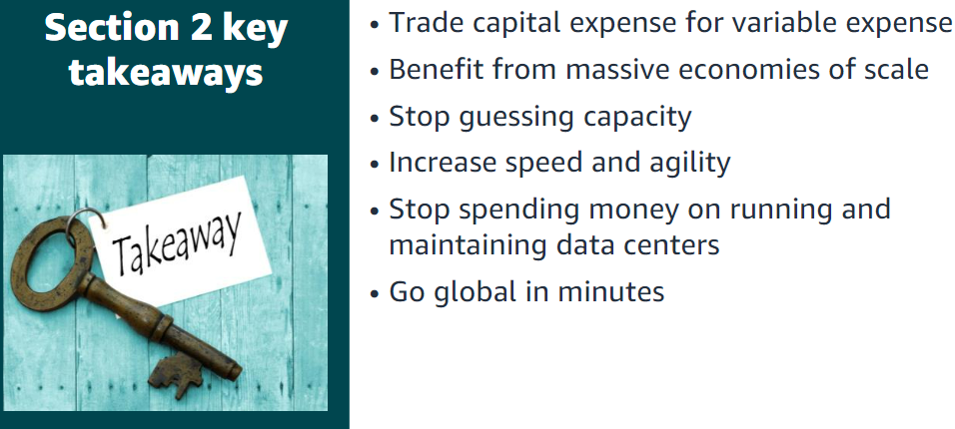

Section 3: Introduction to Amazon

Web Services (AWS)

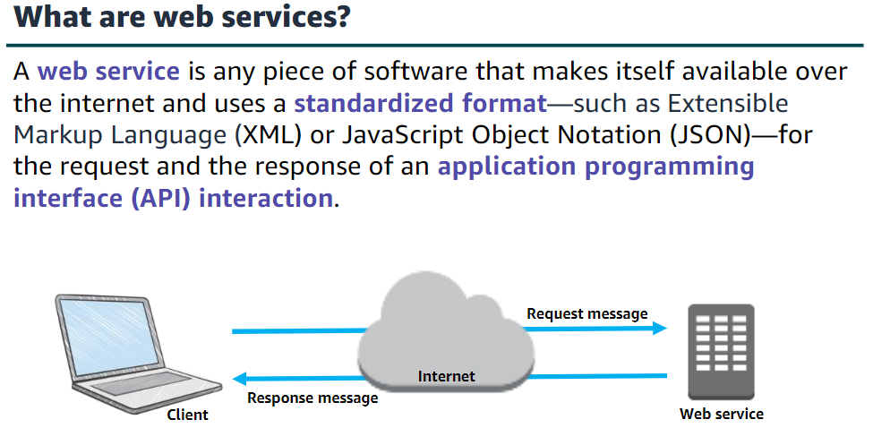

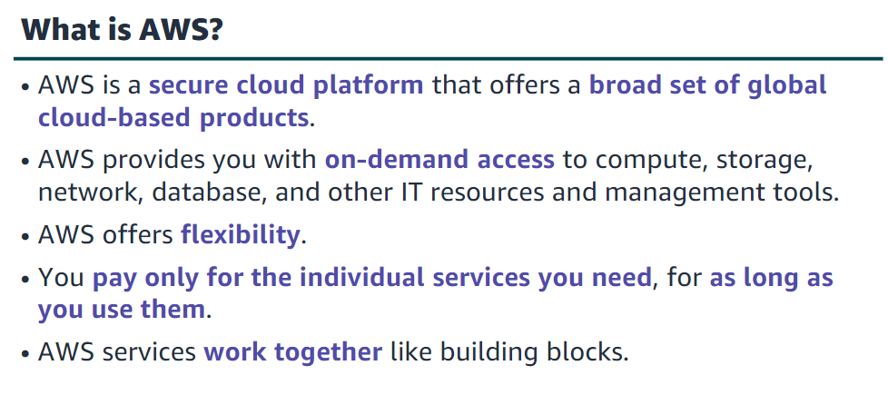

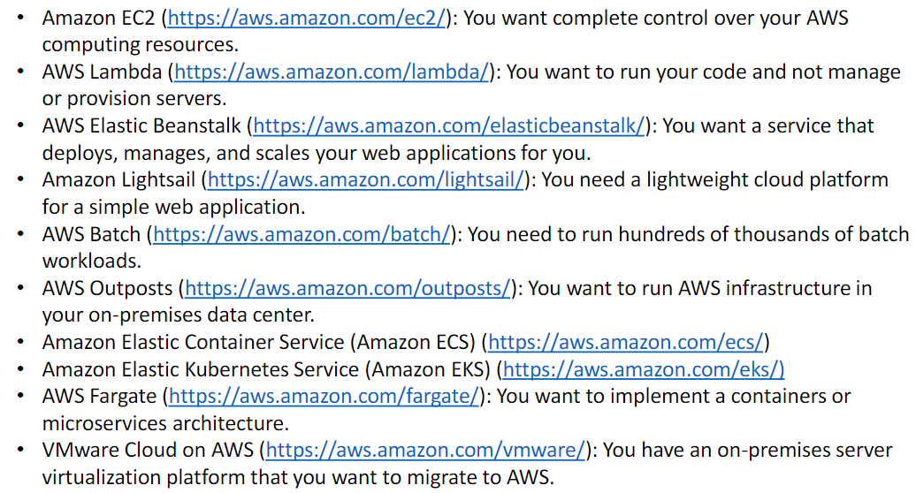

There are three ways to create and manage resources on the AWS Cloud:

**•AWS Management Console**: The console provides a rich graphical interface to a majority of the features offered by AWS.

**•AWS Command Line Interface (AWS CLI):** The AWS CLI provides a suite of utilities that can be launched from a command script in Linux, macOS, or Microsoft Windows.

**•Software development kits (SDKs):** AWS provides packages that enable accessing AWS in a variety of popular programming languages.

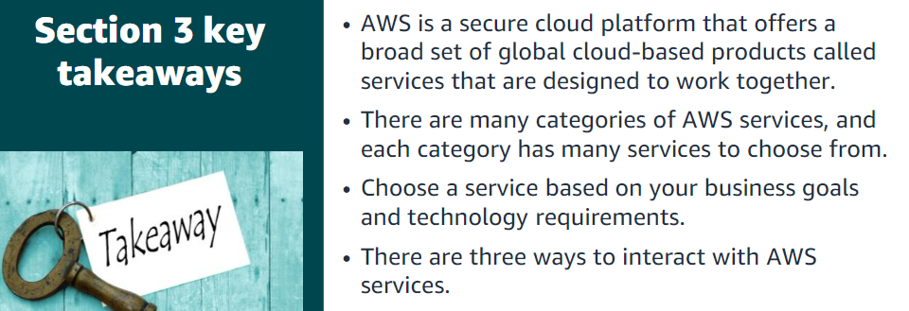

Section 4: Moving to the AWS Cloud –The AWS Cloud Adoption Framework (AWS CAF)

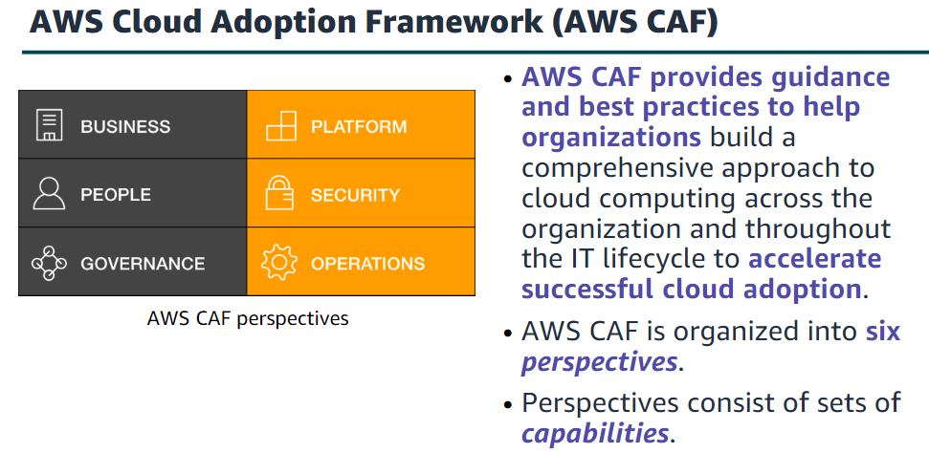

Business V/S Technical

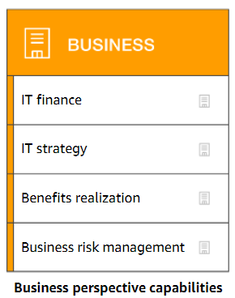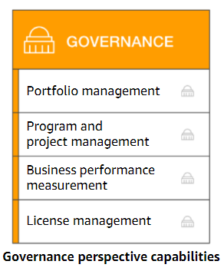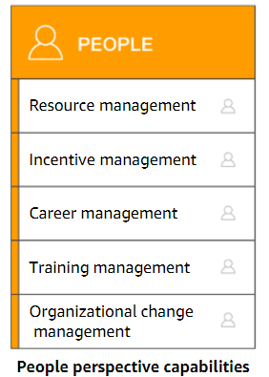

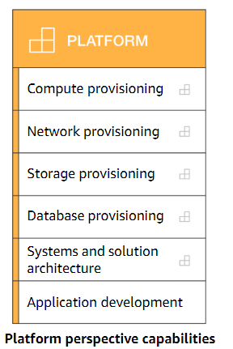

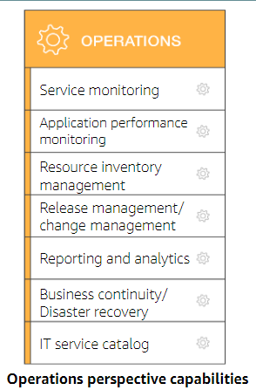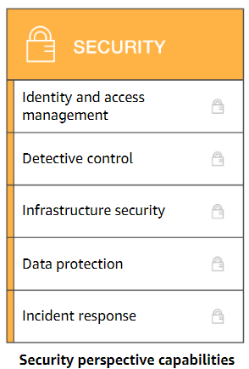

Module 2: Cloud Economics and Billing

Section 1: Fundamentals of pricing

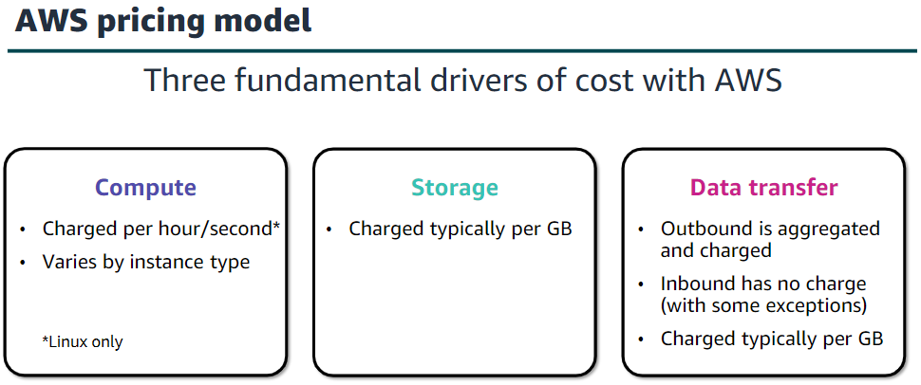

AWS offers a range of cloud computing services. For each service, you pay for exactly the amount of resources that you actually need. This utility-style pricing model includes:

•Pay for what you use

•Pay less when you reserve

•Pay less when you use more

•Pay even less as AWS grows

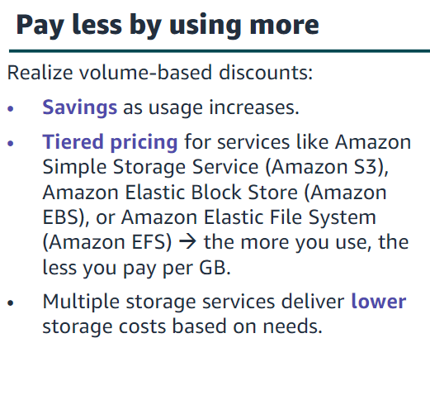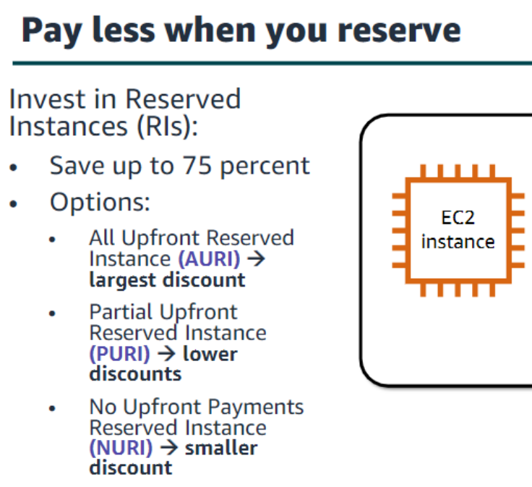

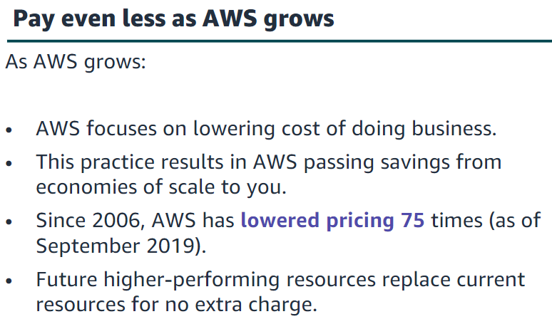

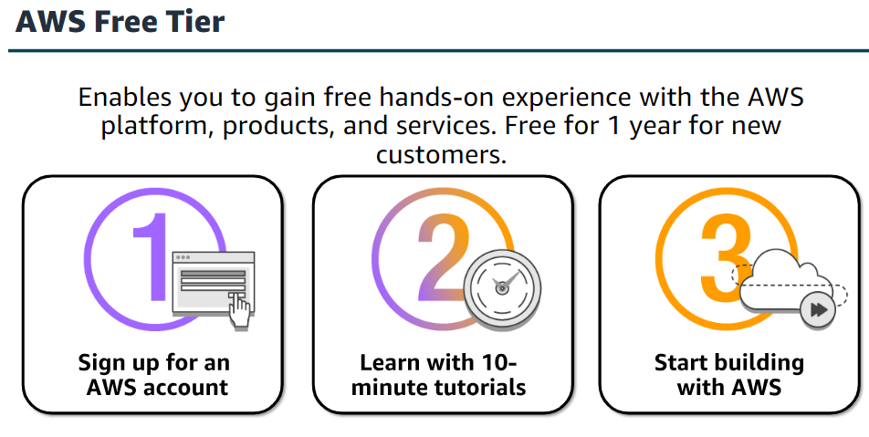

•Amazon Virtual Private Cloud (Amazon VPC) enables you to provision a logically isolated section of the AWS Cloud where you can launch AWS resources in a virtual network that you define.

•AWS Identity and Access Management (IAM) controls your users’ access to AWS services and resources.

•Consolidated Billing is a billing feature in AWS Organizations to consolidate payment for multiple AWS accounts or multiple Amazon Internet Services Private Limited (AISPL) accounts*.

Consolidated billing provides:

•One bill for multiple accounts.

•The ability to easily track each account’s charges.

•The opportunity to decrease charges as a result of volume pricing discounts from

combined usage.

•And you can consolidate all of your accounts using Consolidated Billing and get tiered benefits.

•AWS Elastic Beanstalk is an even easier way for you to quickly deploy and manage applications in the AWS Cloud.

• AWS CloudFormation gives developers and systems administrators an easy way to create a collection of related AWS resources and provision them in an orderly and predictable fashion.

•Automatic Scaling automatically adds or removes resources according to conditions you define. The resources you are using increase seamlessly during demand spikes to maintain performance and decrease automatically during demand lulls to minimize costs.

•AWS OpsWorks is an application management service that makes it easy to deploy and operate applications of all shapes and sizes.

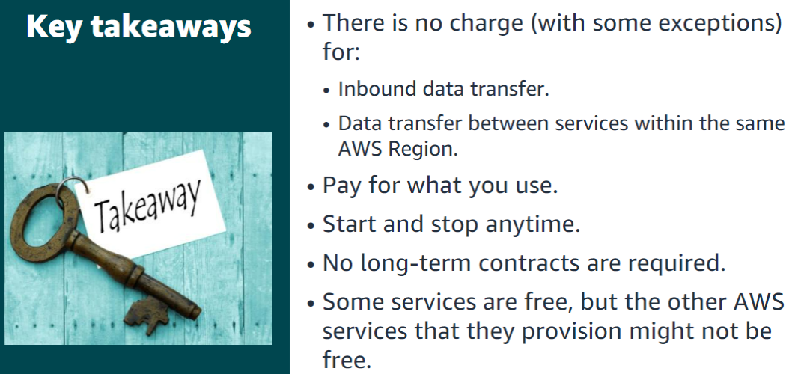

Section 2: Total Cost of Ownership

Total Cost of Ownership (TCO) is the financial estimate to help identify direct and indirect costs of a system

Some of the costs that are associated with data center management include: •Server costs for both hardware and software, and facilities costs to house the equipment.   
•Storage costs for the hardware, administration, and facilities.   
•Network costs for hardware, administration, and facilities.   
•And IT labour costs that are required to administer the entire solution.

Section 3: AWS Organizations

AWS Organizations is a free account management service that enables you to consolidate multiple AWS accounts into an organization that you create and centrally manage.

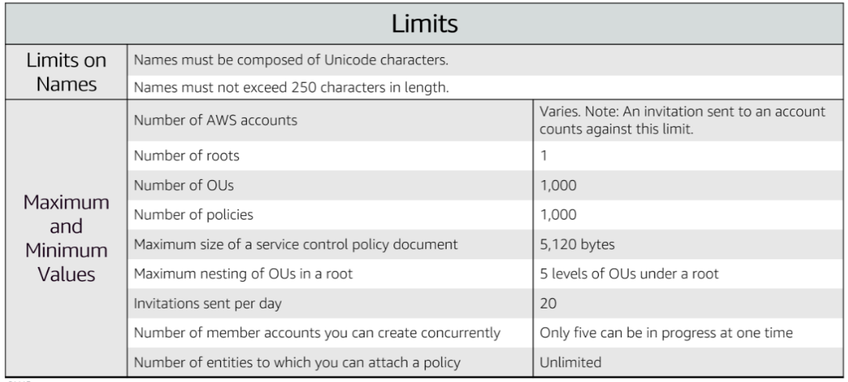

AWS Organizations can be managed through different interfaces.

The AWS Management Console is a browser-based interface that you can use to manage your organization and your AWS resources. You can perform any task in your organization by using the console.

AWS Command Line Interface(AWS CLI) tools enable you to issue commands at your system's command line to perform AWS Organizations tasks and AWS tasks. This method can be faster and more convenient than using the console.

You can use also AWS software development kits (SDKs) to handle tasks such as cryptographically signing requests, managing errors, and retrying requests automatically. AWS SDKs consist of libraries and sample code for various programming languages and platforms, such as Java, Python, Ruby, .NET, iOS, and Android.

The AWS Organizations HTTPS Query API gives you programmatic access to AWS Organizations and AWS. You can use the API to issue HTTPS requests directly to the service. When you use the HTTPS API, you must include code to digitally sign requests by using your credentials.

Section 4: AWS Billing and Cost Management

AWS Billing and Cost Management is the service that you use to pay your AWS bill, monitor your usage, and budget your costs.  
The AWS Cost and Usage Report Tool enables you to identify opportunities for optimization by understanding your cost and usage data trends and how you are using your AWS implementation.  
The AWS Billing Dashboard lets you view the status of your month-to-date AWS expenditure, identify the services that account for the majority of your overall expenditure, and understand at a high level how costs are trending.  
The AWS Bills page lists the costs that you incurred over the past month for each AWS service, with a further breakdown by AWS Region and linked account.  
The AWS Billing and Cost Management console includes the Cost Explorer page for viewing your AWS cost data as a graph.  
AWS Budgets uses the cost visualization that is provided by Cost Explorer to show you the status of your budgets and to provide forecasts of your estimated costs.  
Budget alerts can be sent via email or via Amazon Simple Notification Service (Amazon SNS).

Section 5: Technical support

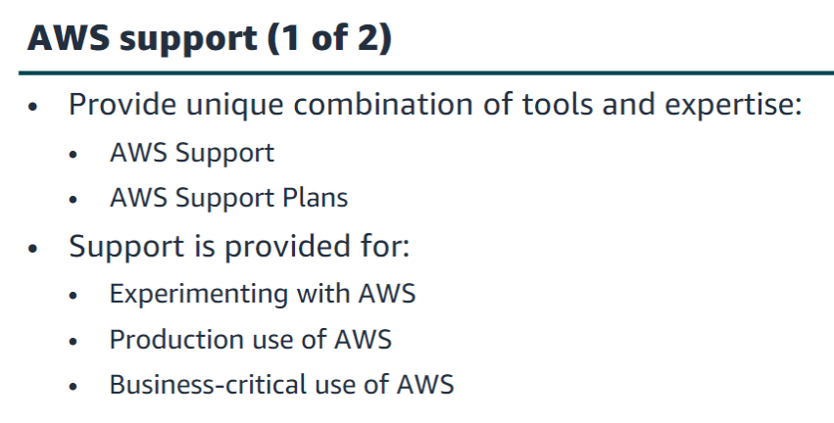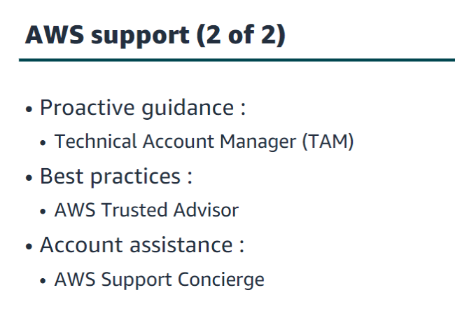

The Basic Support Plan offers:  
•24/7 access to customer service, documentation, whitepapers and support forums.  
•Access to six core Trusted Advisor checks.  
•Access to Personal Health Dashboard.

•The Developer Support Plan offers resources for customers that are testing or doing early development on AWS, and any customers who:  
•Want access to guidance and technical support.  
•Are exploring how to quickly put AWS to work.  
•Use AWS for non-production workloads or applications.

The Business Support Plan offers resources for customers that are running production workloads on AWS and any customers who:  
•Run one or more applications in production environments.  
•Have multiple services activated, or use key services extensively.  
•Depend on their business solutions to be available, scalable, and secure.

There are five different severity levels:

•Critical–Your business is at risk. Critical functions of your application are unavailable.  
•Urgent–Your business is significantly impacted. Important functions of your application are unavailable.  
•High–Important functions of your application are impaired or degraded.  
•Normal–Non-critical functions of your application are behaving abnormally, or you have a time-sensitive development question.  
•Low–You have a general development question, or you want to request a feature.

Module 3: AWS Global Infrastructure Overview

Section 1: AWS Global Infrastructure

The AWS Cloud infrastructure is built around Regions.   
AWS has 22 Regions worldwide. An AWS Region is a physical geographical location with one or more Availability Zones. Availability Zones in turn consist of one or more data centers.  
To achieve fault tolerance and stability, Regions are isolated from one another. Resources in one Region are not automatically replicated to other Regions. When you store data in a specific Region, it is not replicated outside that Region. It is your responsibility to replicate data across Regions, if your business needs require it.   
AWS Regions that were introduced before March 20, 2019 are enabled by default. Regions that were introduced after March 20, 2019—such as Asia Pacific (Hong Kong) and Middle East (Bahrain)—are disabled by default. You must enable these Regions before you can use them. You can use the AWS Management Console to enable or disable a Region. Some Regions have restricted access. An Amazon AWS (China) account provides access to the Beijing and Ningxia Regions only.   
To learn more about AWS in China, see: https://www.amazonaws.cn/en/about-aws/china/. The isolated AWS GovCloud (US) Region is designed to allow US government agencies and customers to move sensitive workloads into the cloud by addressing their specific regulatory and compliance requirements.   
For accessibility: Snapshot from the infrastructure. AWS website that shows a picture of downtown London including the Tower Bridge and the Shard. It notes that there are three Availability Zones in the London region. End of accessibility description.

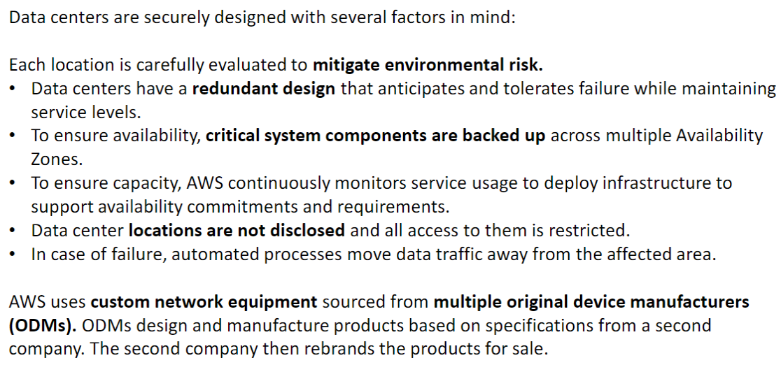

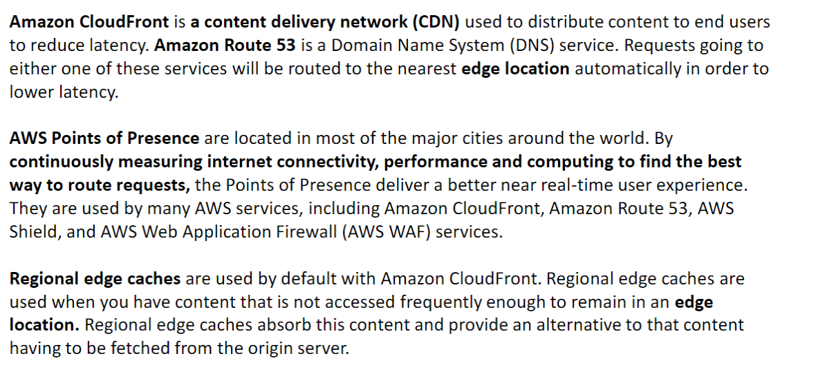

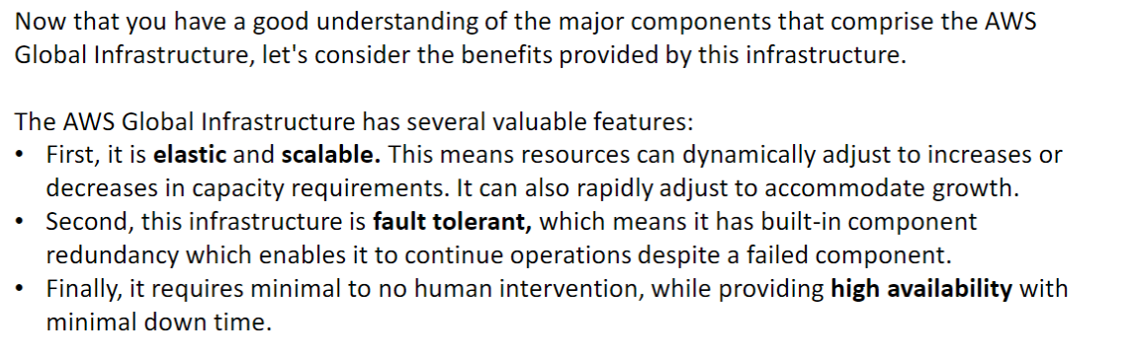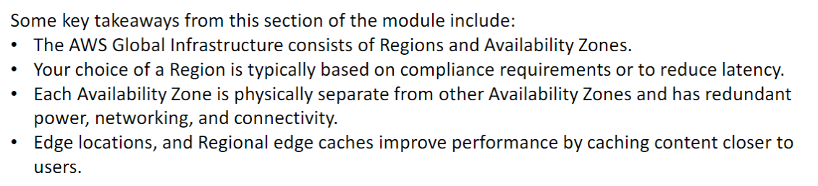

Section 2: AWS services and service category overview

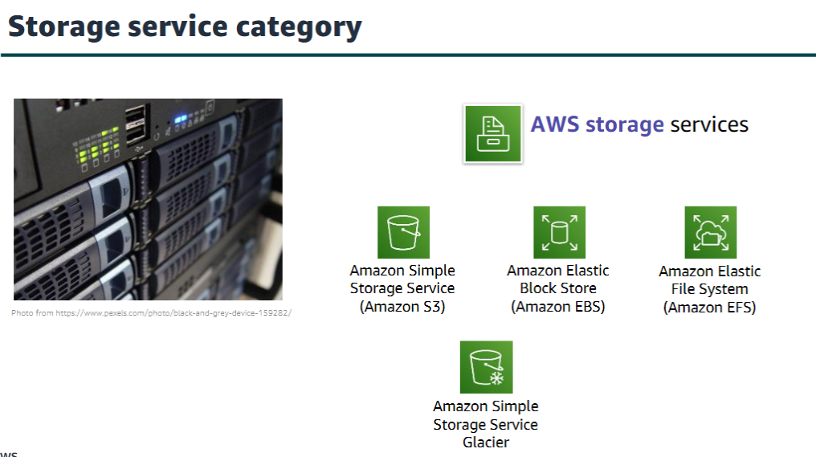

Amazon Simple Storage Service (Amazon S3) is an object storage service that offers scalability, data availability, security, and performance. Use it to store and protect any amount of data for websites, mobile apps, backup and restore, archive, enterprise applications, Internet of Things (IoT) devices, and big data analytics.

Amazon Elastic Block Store (Amazon EBS) is high-performance block storage that is designed for use with Amazon EC2 for both throughput and transaction-intensive workloads. It is used for a broad range of workloads, such as relational and non-relational databases, enterprise applications, containerized applications, big data analytics engines, file systems, and media workflows.

Amazon Elastic File System (Amazon EFS) provides a scalable, fully managed elastic Network File System (NFS) file system for use with AWS Cloud services and on-premises resources. It is built to scale on demand to petabytes, growing and shrinking automatically as you add and remove files. It reduces the need to provision and manage capacity to accommodate growth.

Amazon Simple Storage Service Glacier is a secure, durable, and extremely low-cost Amazon S3 cloud storage class for data archiving and long-term backup. It is designed to deliver 11 9s of durability and to provide comprehensive security and compliance capabilities to meet stringent regulatory requirements.

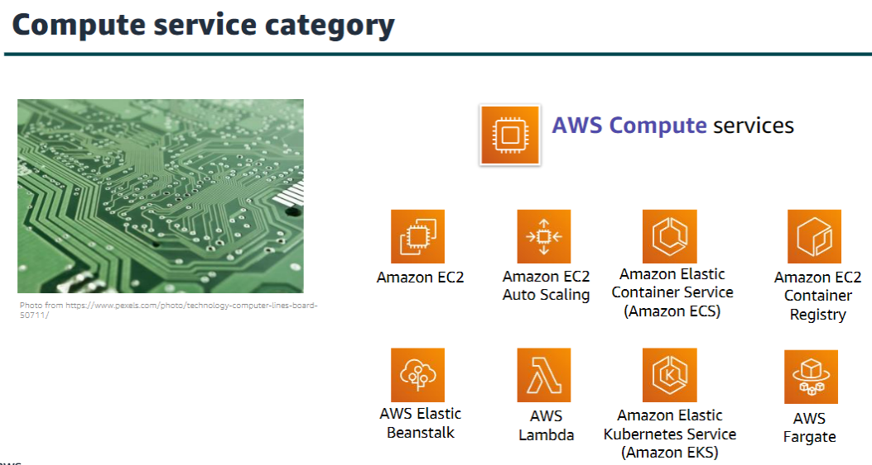

AWS compute services include the services listed here, and many others.   
  
Amazon Elastic Compute Cloud (Amazon EC2) provides resizable compute capacity as virtual machines in the cloud. Amazon EC2 Auto Scaling enables you to automatically add or remove EC2 instances according to conditions that you define.

Amazon Elastic Container Service (Amazon ECS) is a highly scalable, high-performance container orchestration service that supports Docker containers.

Amazon Elastic Container Registry (Amazon ECR) is a fully-managed Docker container registry that makes it easy for developers to store, manage, and deploy Docker container images.

AWS Elastic Beanstalk is a service for deploying and scaling web applications and services on familiar servers such as Apache and Microsoft Internet Information Services (IIS).

AWS Lambda enables you to run code without provisioning or managing servers. You pay only for the compute time that you consume. There is no charge when your code is not running.

Amazon Elastic Kubernetes Service (Amazon EKS) makes it easy to deploy, manage, and scale containerized applications that use Kubernetes on AWS.

AWS Fargate is a compute engine for Amazon ECS that allows you to run containers without having to manage servers or clusters.

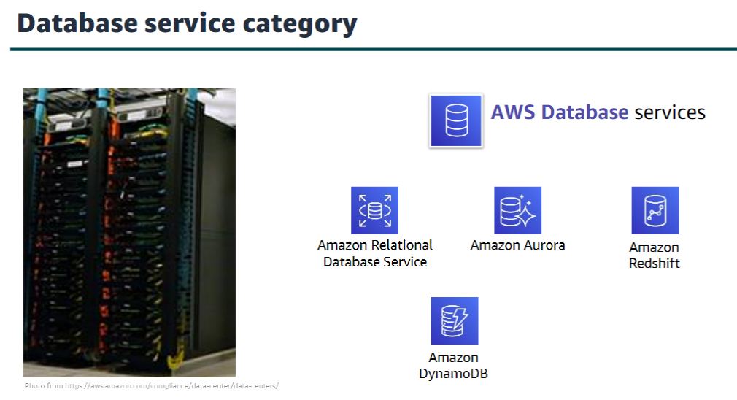

AWS database services include the services listed here, and many others.

Amazon Relational Database Service (Amazon RDS) makes it easy to set up, operate, and scale a relational database in the cloud.   
It provides resizable capacity while automating time-consuming administration tasks such as hardware provisioning, database setup, patching, and backups.

Amazon Aurora is a MySQL and PostgreSQL-compatible relational database.   
It is up to five times faster than standard MySQLdatabases and three times faster than standard PostgreSQL databases.

Amazon Redshift enables you to run analytic queries against petabytes of data that is stored locally in Amazon Redshift, and directly against exabytes of data that are stored in Amazon S3. It delivers fast performance at any scale.

Amazon DynamoDB is a key-value and document database that delivers single-digit millisecond performance at any scale, with built-in security, backup and restore, and in-memory caching

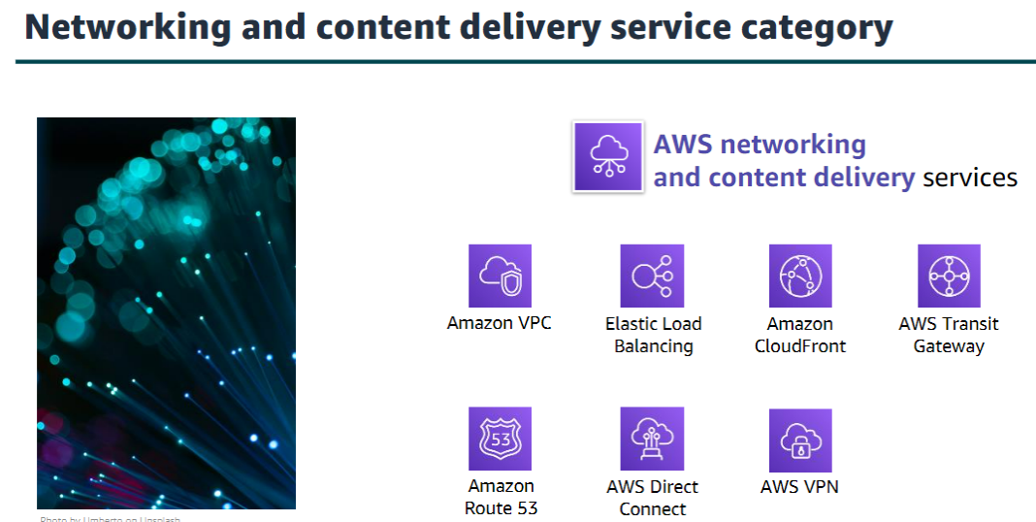

Amazon Virtual Private Cloud (Amazon VPC) enables you to provision logically isolated sections of the AWS Cloud.

Elastic Load Balancing automatically distributes incoming application traffic across multiple targets, such as Amazon EC2 instances, containers, IP addresses, and Lambda functions.

Amazon CloudFront is a fast content delivery network (CDN) service that securely delivers data, videos, applications, and application programming interfaces (APIs) to customers globally, with low latency and high transfer speeds.

AWS Transit Gateway is a service that enables customers to connect their Amazon Virtual Private Clouds (VPCs) and their on-premises networks to a single gateway.

Amazon Route 53 is a scalable cloud Domain Name System (DNS) web service designed to give you a reliable way to route end users to internet applications. It translates names (like www.example.com) into the numeric IP addresses (like 192.0.2.1) that computers use to connect to each other.

AWS Direct Connect provides a way to establish a dedicated private network connection from your data center or office to AWS, which can reduce network costs and increase bandwidth throughput.

AWS VPN provides a secure private tunnel from your network or device to the AWS global network.

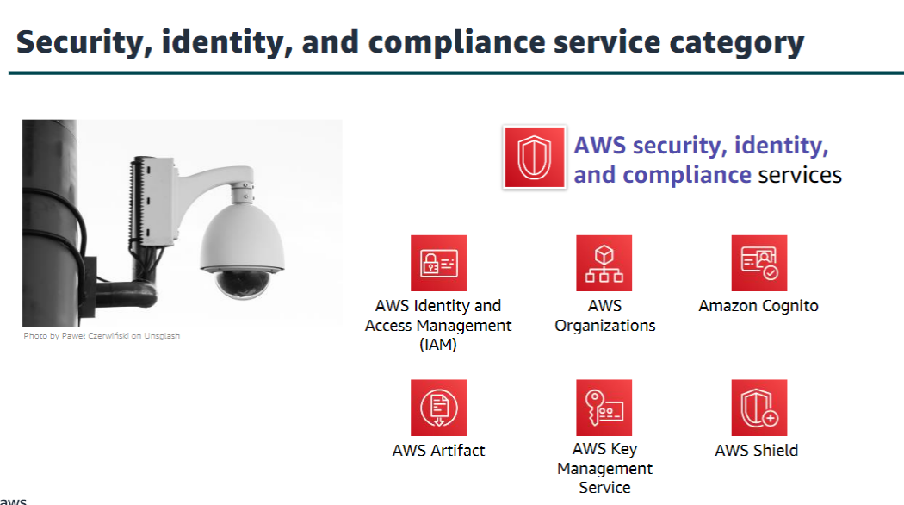

AWS Identity and Access Management (IAM) enables you to manage access to AWS services and resources securely. By using IAM, you can create and manage AWS users and groups. You can use IAM permissions to allow and deny user and group access to AWS resources.

AWS Organizations allows you to restrict what services and actions are allowed in your accounts.

Amazon Cognito lets you add user sign-up, sign-in, and access control to your web and mobile apps.

AWS Artifact provides on-demand access to AWS security and compliance reports and select online agreements.

AWS Key Management Service (AWS KMS) enables you to create and manage keys. You can use AWS KMS to control the use of encryption across a wide range of AWS services and in your applications.

AWS Shield is a managed Distributed Denial of Service (DDoS) protection service that safeguards applications running on AWS.

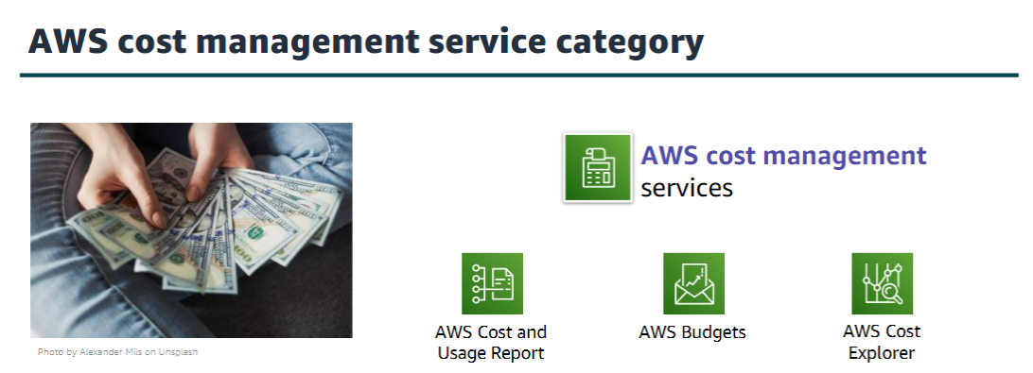

The AWS Cost and Usage Report contains the most comprehensive set of AWS cost and usage data available, including additional metadata about AWS services, pricing, and reservations.

AWS Budgets enables you to set custom budgets that alert you when your costs or usage exceed (or are forecasted to exceed) your budgeted amount.

AWS Cost Explorer has an easy-to-use interface that enables you to visualize, understand, and manage your AWS costs and usage over time.

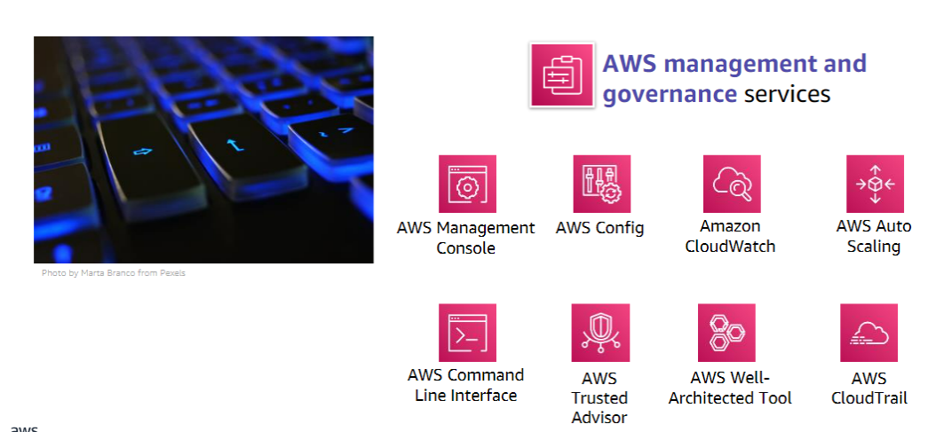

The AWS Management Console provides a web-based user interface for accessing your AWS account.

AWS Config provides a service that helps you track resource inventory and changes.

Amazon CloudWatch allows you to monitor resources and applications.

AWS Auto Scaling provides features that allow you to scale multiple resources to meet demand.

AWS Command Line Interface provides a unified tool to manage AWS services.

AWS Trusted Advisor helps you optimize performance and security.

AWS Well-Architected Tool provides help in reviewing and improving your workloads.

AWS CloudTrail tracks user activity and API usage.

Module 4: AWS Cloud Security

Section 1: AWS shared

responsibility model

The differentiation of who is responsible for what is commonly referred to as security “of” the cloud versus security “in” the cloud.

AWS operates, manages, and controls the components from the software virtualization layer down to the physical security of the facilities where AWS services operate. AWS is responsible for protecting the infrastructure that runs all the services that are offered in the AWS Cloud. This infrastructure is composed of the hardware, software, networking, and facilities that run the AWS Cloud services.

The customer is responsible for the encryption of data at rest and data in transit. The customer should also ensure that the network is configured for security and that security credentials and logins are managed safely. Additionally, the customer is responsible for the configuration of security groups and the configuration of the operating system that run on compute instances that they launch (including updates and security patches.

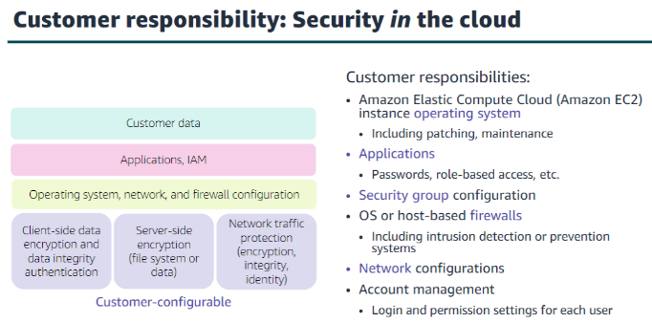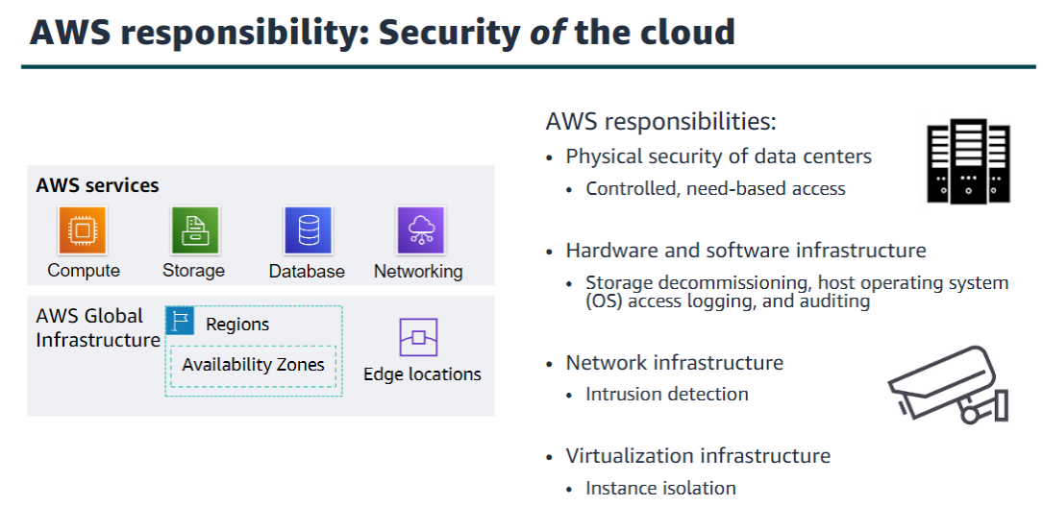

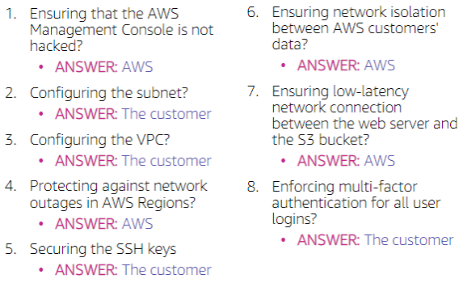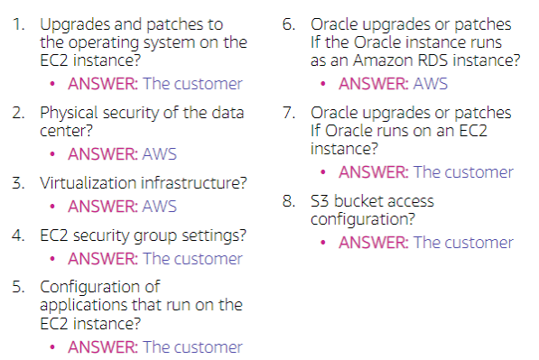

Section 2: AWS Identity and Access Management (IAM)

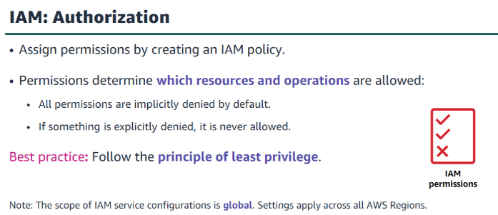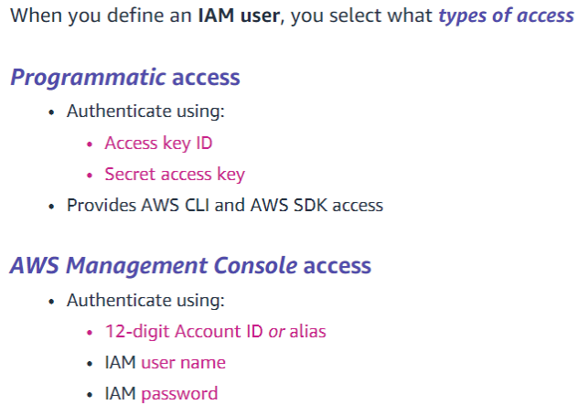

An explicit deny statement takes precedence over an allow statement.

Resource-based policies are defined inline only, which means that you define the policy on the resource itself, instead of creating a separate IAM policy document that you attach.

An IAM Group is a collection of IAM users. IAM groups offer a convenient way to specify permissions for a collection of users, which can make it easier to manage the permissions for those users.

Important characteristics of IAM groups:

• A group can contain many users, and a user can belong to multiple groups.

• Groups cannot be nested. So a group can contain only users, and a group cannot contain other groups.

• There is no default group that automatically includes all users in the AWS account. If you want

to have a group with all account users in it, you need to create the group and add each new user to it.

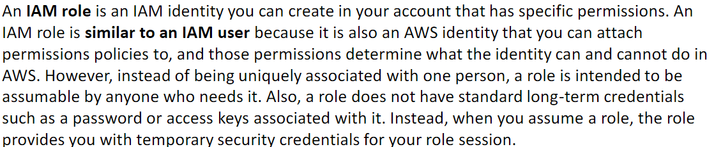

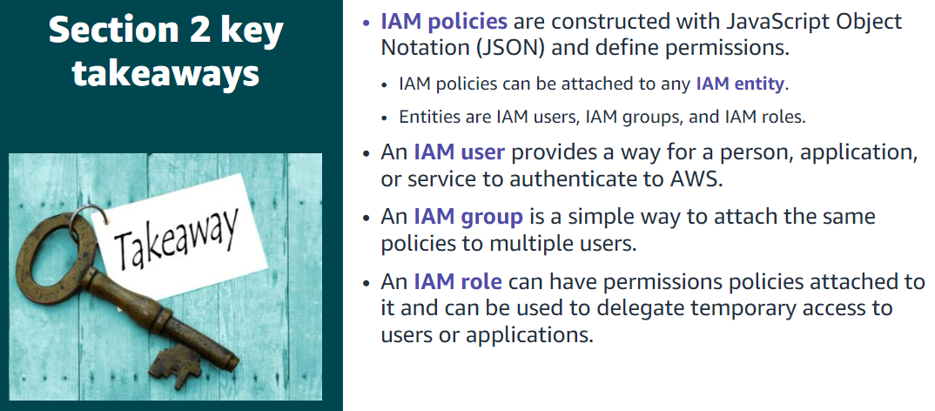

Section 3: Securing a new AWS account

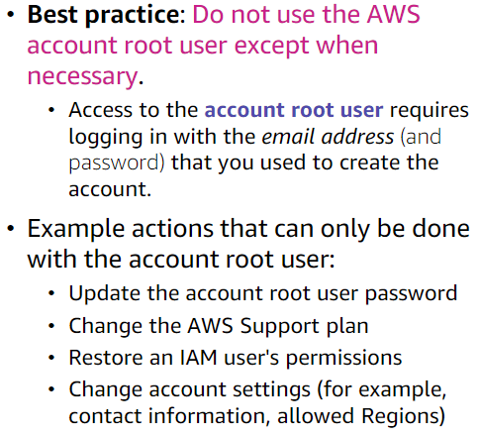

AWS CloudTrail is enabled on account creation by default on all AWS accounts, and it keeps a record of the last 90 days of account management event activity.

You can view and download the last 90 days of your account activity for creating, modifying, and deleting related operations of services that are supported by CloudTrail without needing to manually create another trail.

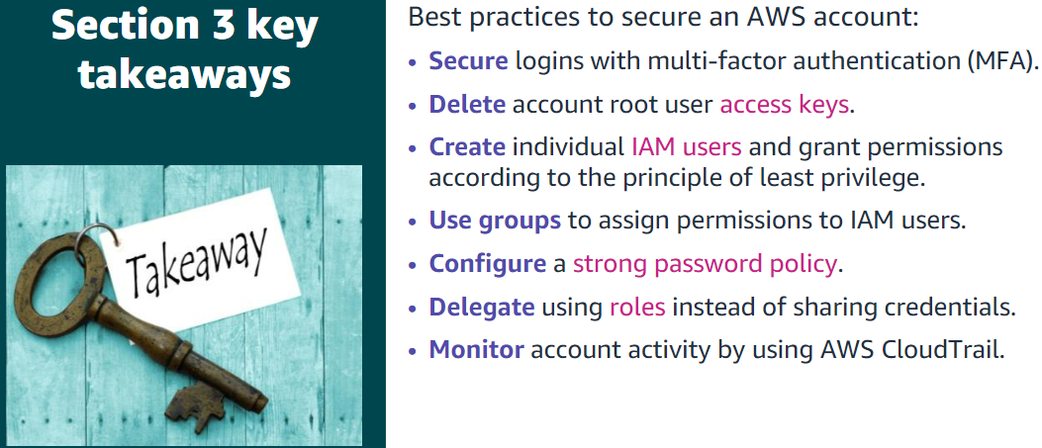

Section 4: Securing accounts

AWS Organizations is an account management service that enables you to consolidate multiple AWS accounts into an organization that you create and centrally manage. Here, the focus is on the security features that AWS Organizations provides. One helpful security feature is that you can group accounts into organizational units(OUs) and attach different access policies to each OU.

Another security feature is that AWS organizations integrate with and supports IAM. AWS Organizations expands that control to the account level by giving you control over what users and roles in an account or a group of accounts can do.

Finally, AWS Organizations provides service control policies (SCPs) that enable you to specify the maximum permissions that member accounts in the organization can have. In SCPs, you can restrict which AWS services, resources, and individual actions the users and roles in each member account can access. These restrictions even override the administrators of member accounts. When AWS Organizations blocks access to a service, resource, or API action, a user or role in that account can't access it, even if an administrator of a member account explicitly grants such permissions.

SCPs are similar to IAM permissions policies – •They use similar syntax.

•However, an SCP never grants permissions.

•Instead, SCPs specify the maximum permissions for an organization.

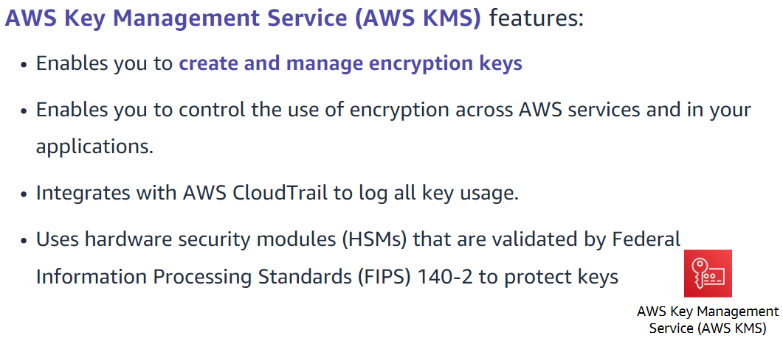

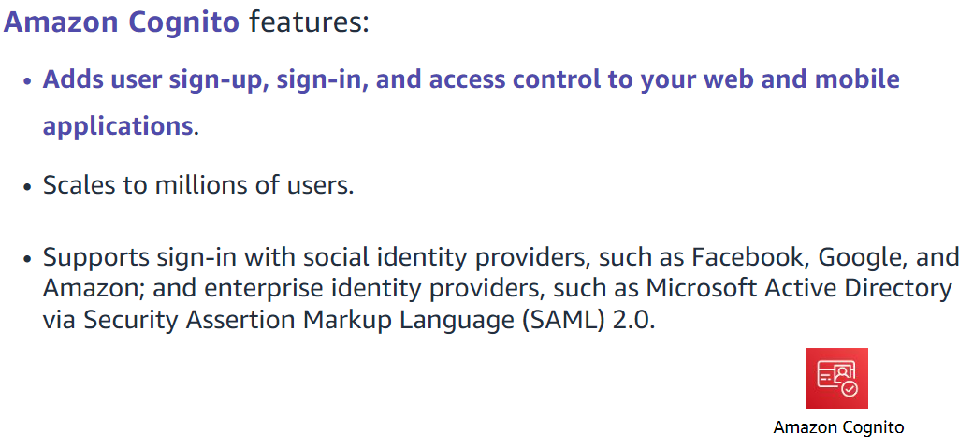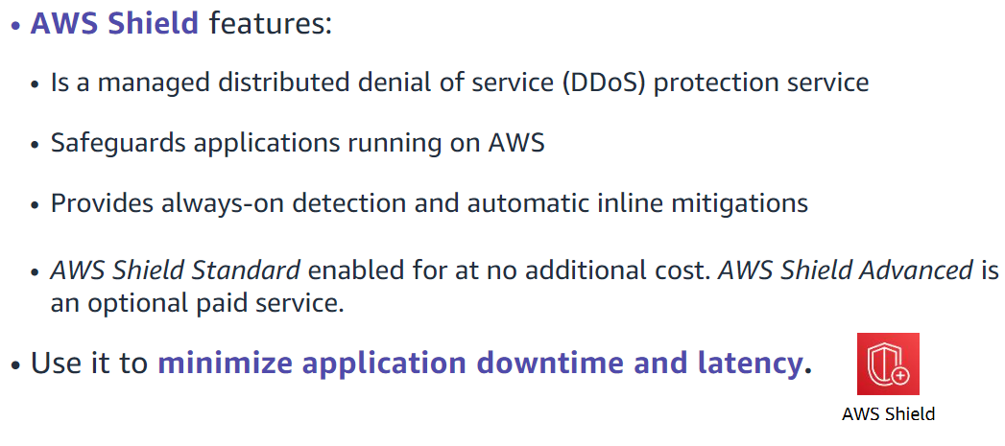

Section 5: Securing data on

AWS

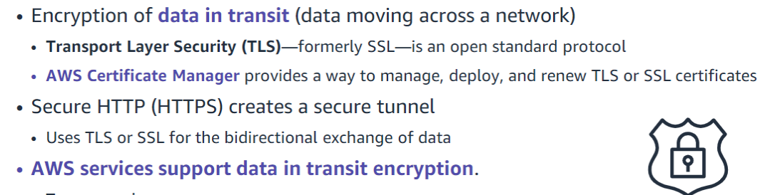

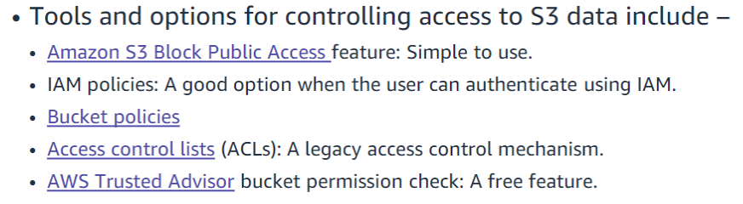

Section 6: Working to ensure

compliance

•Compliance programs can be broadly categorized –

•Certifications and attestations

•Assessed by a third-party, independent auditor

•Examples: ISO27001,27017,27018, and ISO/IEC9001

•Laws, regulations, and privacy

•AWS provides security features and legal agreements to support compliance

•Examples: EU General Data Protection Regulation (GDPR), HIPAA

•Alignments and frameworks

•Industry-or function-specific security or compliance requirements

•Examples: Center for Internet Security (CIS), EU-US Privacy Shield certified

AWS Config

•Assess, audit, and evaluate the configurations of AWS resources.

AWS Artifact

•Is a resource for compliance-related information

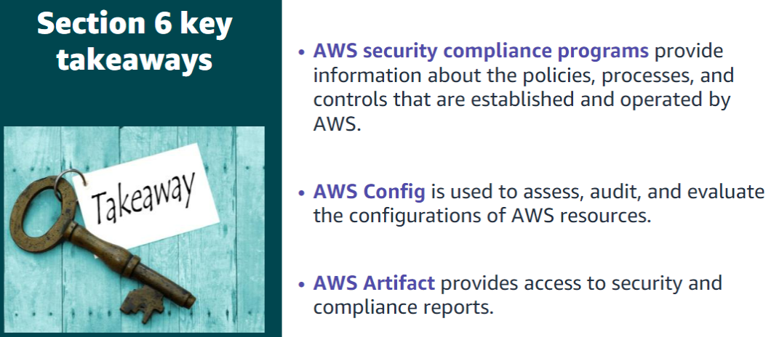

Module 5: Networking and Content Delivery

Section 1: Networking basics

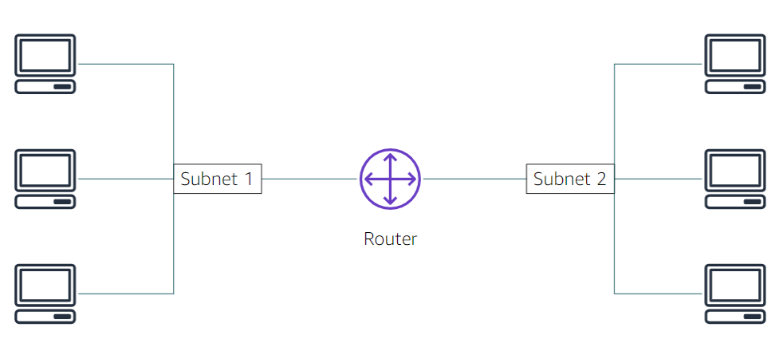

Each client machine in a network has a unique Internet Protocol (IP) address that identifies it. An IP address is a numerical label in decimal format. Machines convert that decimal number to a binary format.

In this example, the IP address is 192.0.2.0.

Each of the four dot (.)-separated numbers of the IP address represents 8 bits in octal number format. That means each of the four numbers can be anything from 0 to 255. The combined total of the four numbers for an IP address is 32 bits in binary format.

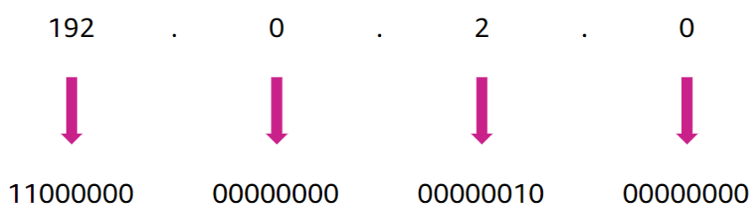

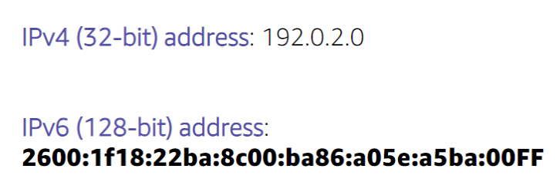

An IPv6 address is composed of eight groups of four letters and numbers that are separated by colons (:). In this example, the IPv6 address is 2600:1f18:22ba:8c00:ba86:a05e:a5ba:00FF.

Each of the eight colon-separated groups of the IPv6 address represents 16 bits in hexadecimal number format. That means each of the eight groups can be anything from 0 to FFFF. The combined total of the eight groups for an IPv6 address is 128 bits in binary format

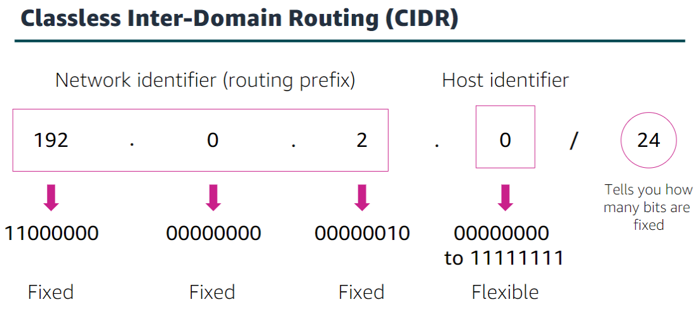

The internet, in which every bit is flexible, is represented as 0.0.0.0/0

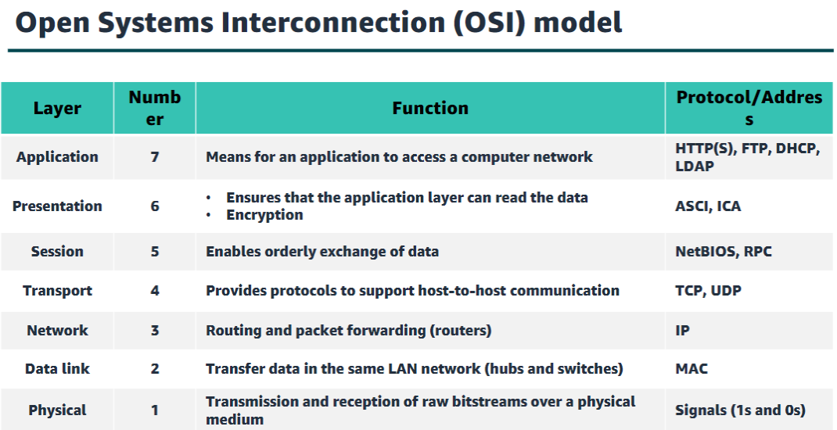

Please Do Not Touch Selvi’s Pet Anish

Section 2: Amazon VPC

Amazon Virtual Private Cloud (Amazon VPC) is a service that lets you provision a logically isolated section of the AWS Cloud (called a virtual private cloud, or VPC) where you can launch your AWS resources.

Amazon VPC gives you control over your virtual networking resources, including the selection of your own IP address range, the creation of subnets, and the configuration of route tables and network gateways. You can use both IPv4 and IPv6 in your VPC for secure access to resources and applications. You can use multiple layers of security, including security groups and network access control lists (networkACLs), to help control access to Amazon Elastic Compute Cloud (Amazon EC2) instances in each subnet.

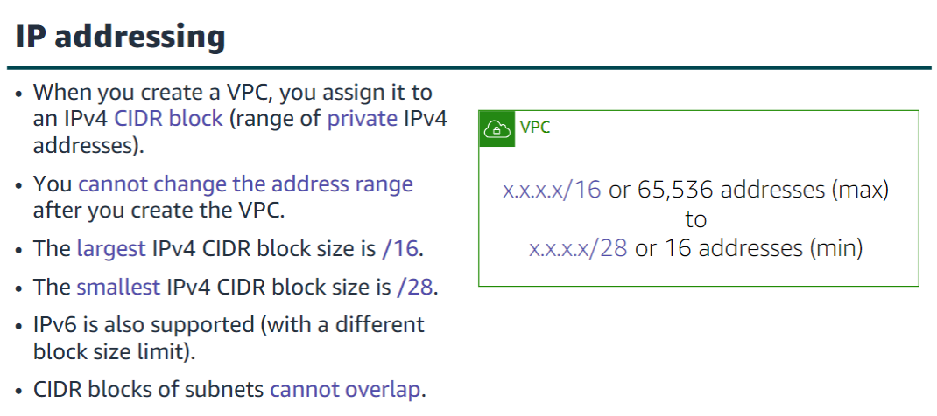

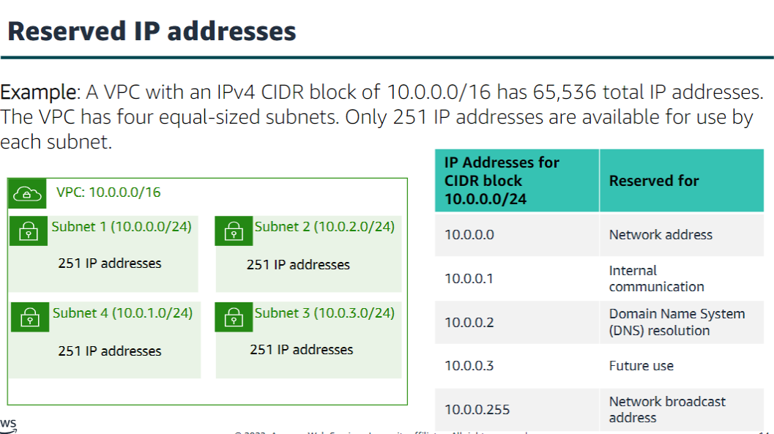

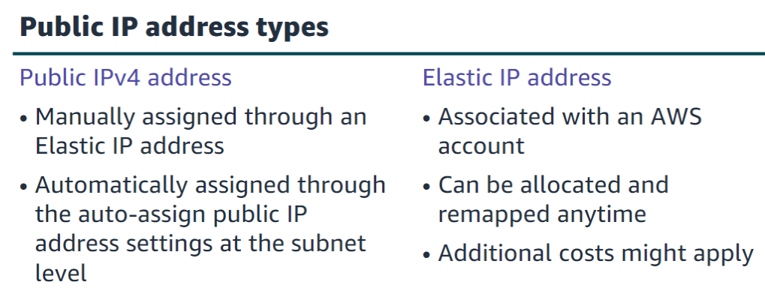

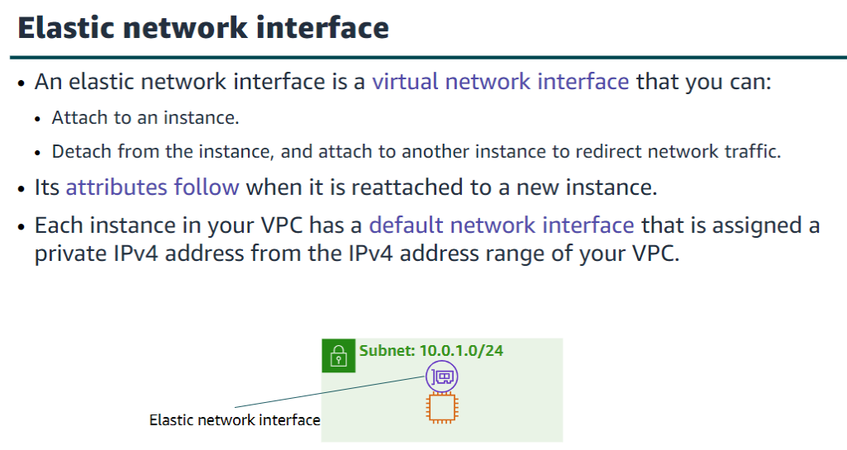

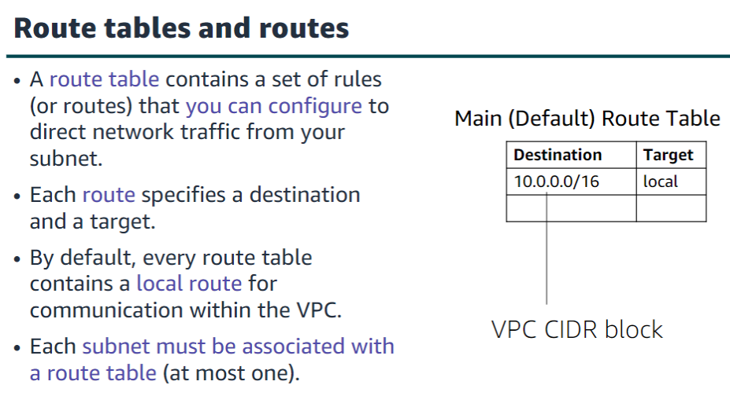

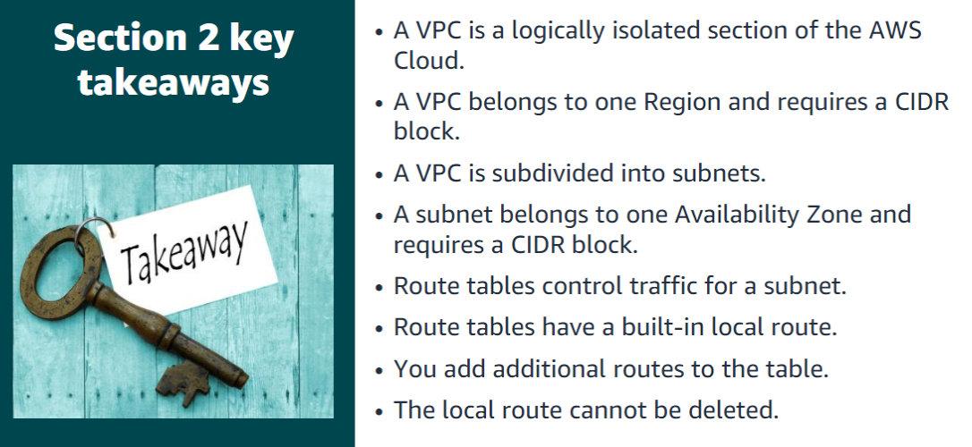

Section 3: VPC networking

An internet gatewayis a scalable, redundant, and highly available VPC component that allows communication between instances in your VPC and the internet. An internet gateway serves two purposes: to provide a target in your VPC route tables for internet-routable traffic, and to perform network address translation for instances that were assigned public IPv4 addresses.

To make a subnet public, you attach an internet gateway to your VPC and add a route to the route table to send non-local traffic through the internet gateway to the internet (0.0.0.0/0).

A network address translation (NAT) gatewayenables instances in a private subnet to connect to the internet or other AWS services, but prevents the internet from initiating a connection with those instances.

To create a NAT gateway, you must specify the public subnet in which the NAT gateway should reside. You must also specify an Elastic IP address to associate with the NAT gateway when you create it. After you createa NAT gateway, you must update the route table thatis associated with one or more of your private subnets to point internet-bound traffic to the NAT gateway.

Thus, instances in your private subnets can communicate with the internet. You can also use a NAT instance in a public subnet in your VPC instead of a NAT gateway. However, a NAT gateway is a managed NAT service that provides better availability, higher bandwidth, and less administrative effort. For common use cases, AWS recommends that you use a NAT gateway instead of a NAT instance.

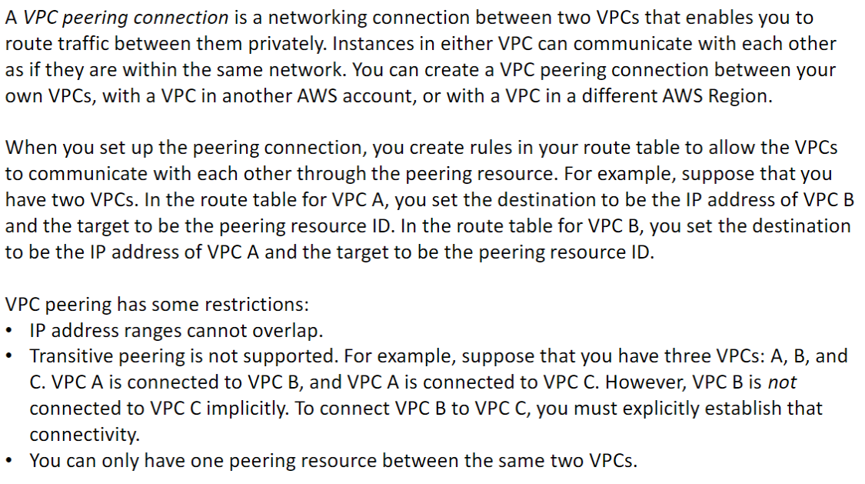

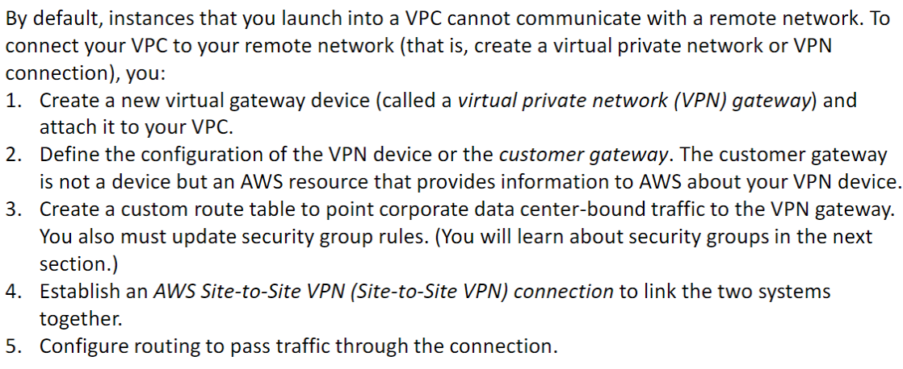

AWS Direct Connect enables you to establish a dedicated, private network connection between your network and one of the DX locations.

A VPC endpointis a virtual device that enables you to privately connect your VPC to supported AWS services and VPC endpoint services that are powered by AWS PrivateLink. Connection to these services does not require an internet gateway, NAT device, VPN connection, or AWS Direct Connect connection.

There are two types of VPC endpoints:

•An interface VPC endpoint(interface endpoint) enables you to connect to services that are powered by AWS PrivateLink. These services include some AWS services, services that are hosted by other AWS customers and AWS Partner Network (APN) Partners in their own VPCs (referred to as endpoint services), and supported AWS Marketplace APN Partner services. The owner of the service is the service provider, and you—as the principal who creates the interface endpoint—are the service consumer. You are charged for creating and using an interface endpoint to a service. Hourly usage rates and data processing rates apply. See the AWS Documentation for a list of supported interface endpoints and for more information about the example shown here at <https://docs.aws.amazon.com/vpc/latest/privatelink/create-interface-endpoint.html>.

•Gateway endpoints: The use of gateway endpoints incurs no additional charge. Standard charges for data transfer and resource usage apply.

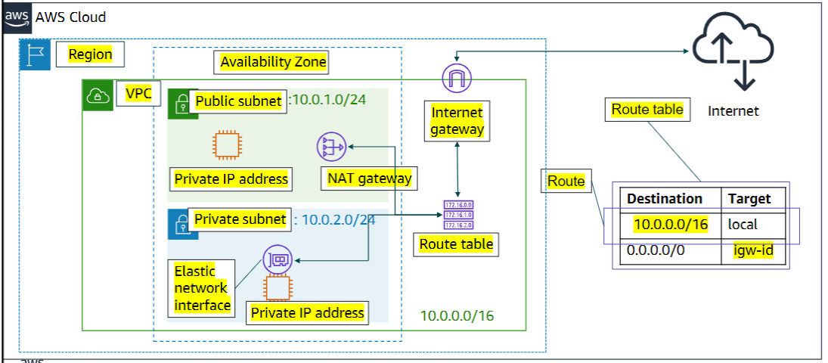

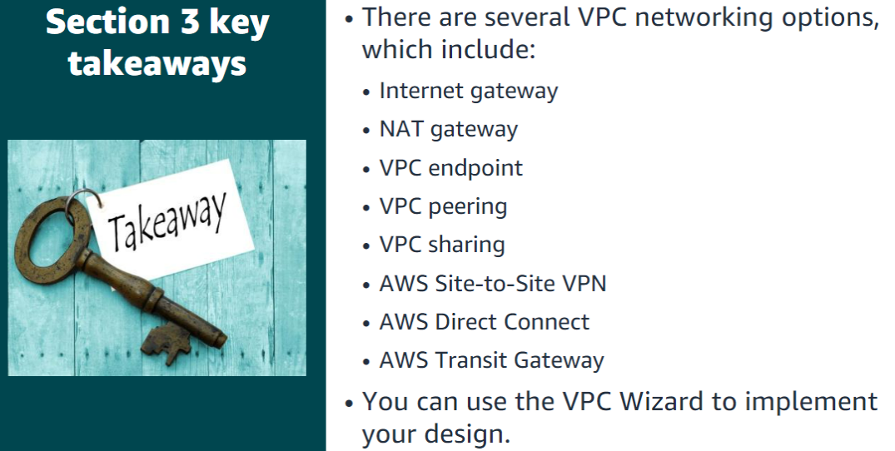

Section 4: VPC security

A security groupacts as a virtual firewall for your instance, and it controls inbound and outbound traffic. Security groups act at the instance level, not the subnet level. Therefore, each instance in a subnet in your VPC can be assigned to a different set of security groups.   
At the most basic level, a security group is a way for you to filter traffic to your instances

Security groups have rules that control inbound and outbound instance traffic.

•Default security groups deny all inbound traffic and allow all outbound traffic.  
•Security groups are stateful, which means that state information is kept even after a request is processed.

A network access control list (network ACL)is an optional layer of security for your Amazon VPC. It acts as a firewall for controlling traffic in and out of one or more subnets.

•A network ACL has separate inbound and outbound rules, and each rule can either allow or deny traffic.  
•Default network ACLs allow all inbound and outbound IPv4 traffic.  
•Network ACLs are stateless, which means that no information about a request is maintained after a request is processed.

Custom network ACLs deny all inbound and outbound traffic until you add rules.  
•You can specify both allow and deny rules.   
•Rules are evaluated in number order, starting with the lowest number.

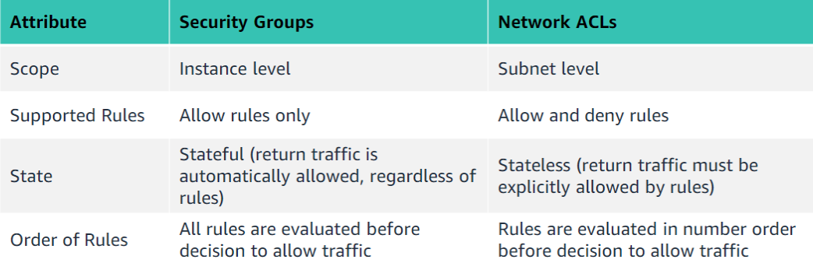

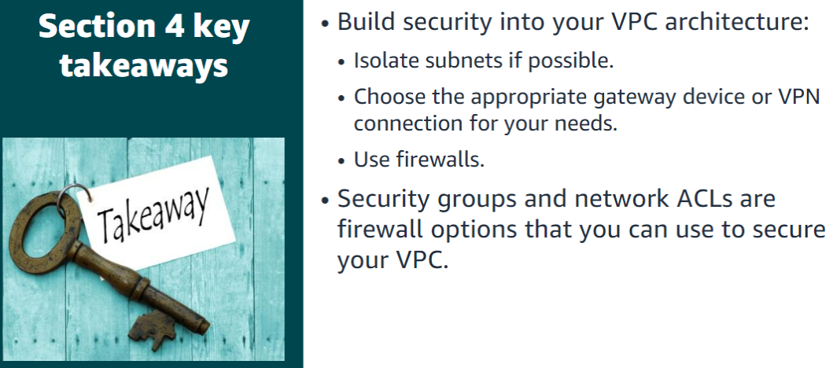

Section 5: Amazon Route 53

Amazon Route 53 is a highly available and scalable cloud Domain Name System (DNS) web service. It is designed to give developers and businesses areliable and cost-effective way to route users to internet applications by translating names (like www.example.com) into the numeric IP addresses (like 192.0.2.1) that computers use to connect to each other. In addition, Amazon Route 53 is fully compliant with IPv6.

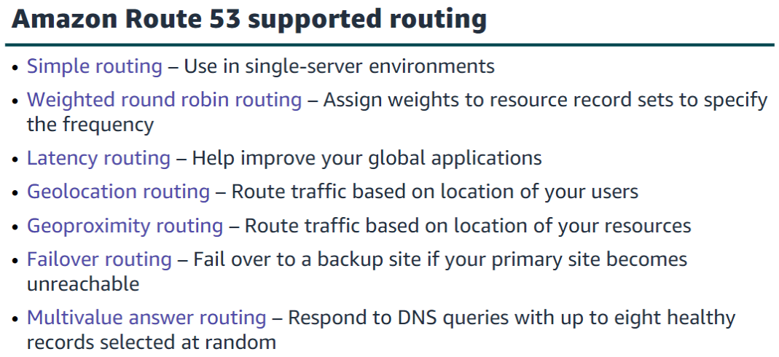

Simple routing is based on round robin

Amazon Route 53 enables you to improve the availability of your applications that run on AWS by:  
•Configuring backup and failover scenarios for your own applications.  
•Enabling highly available multi-Region architectures on AWS.  
•Creating health checks to monitor the health and performance of your web applications, web servers, and other resources.

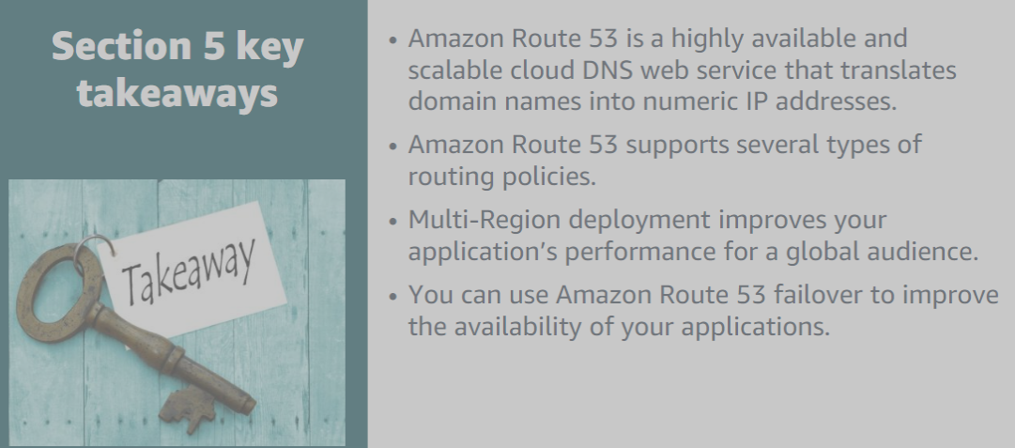

Section 6: Amazon CloudFront

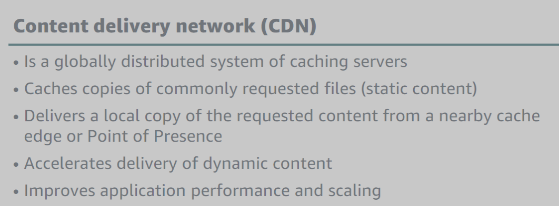

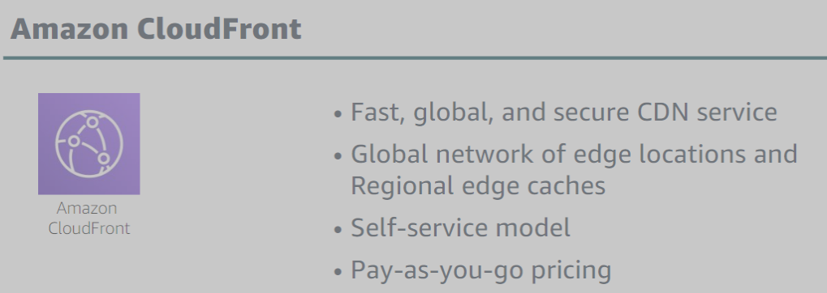

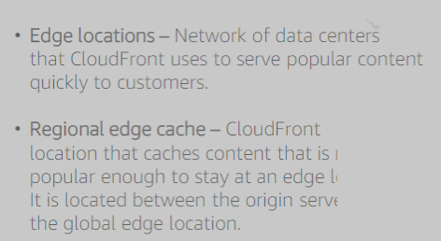

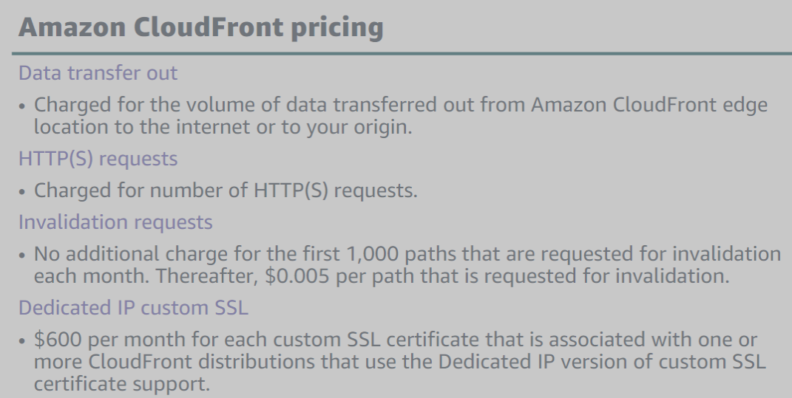

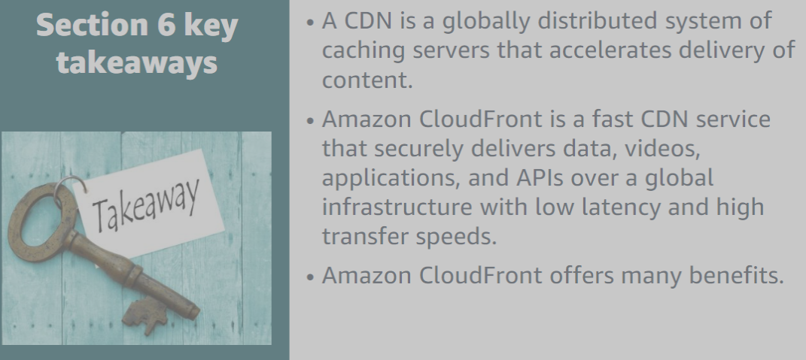

Module 6: Compute

Section 1: Compute services overview

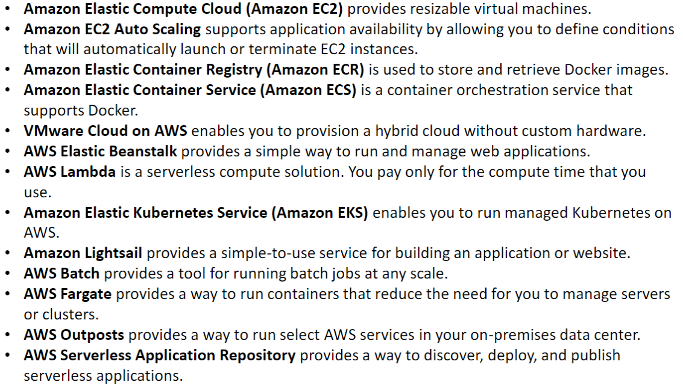

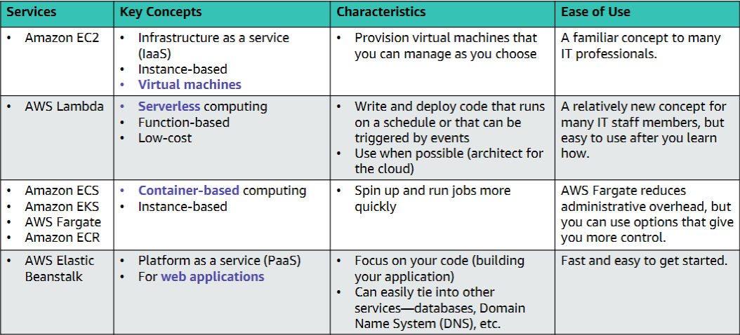

Section 2: Amazon EC2

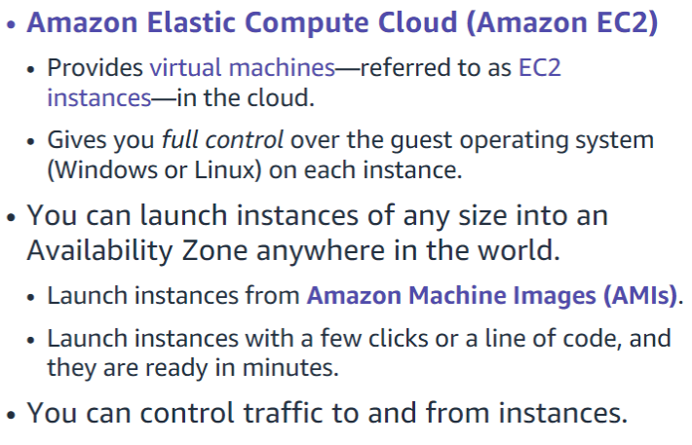

This section of the module walks through nine key decisions to make when you create an EC2 instance by using the AWS Management Console Launch Instance Wizard

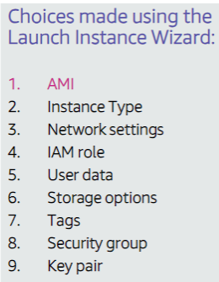

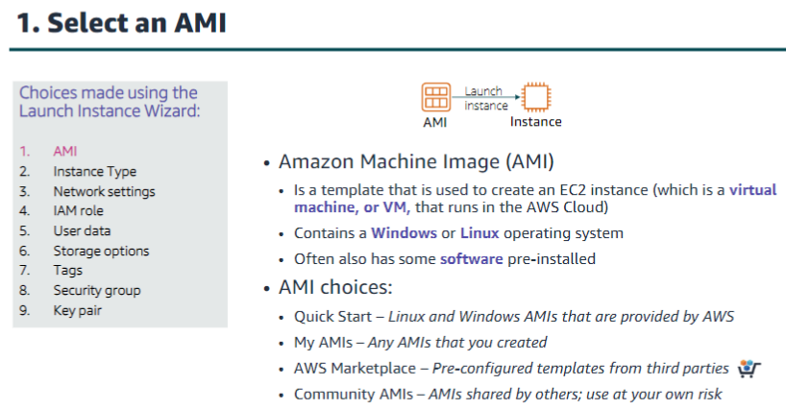

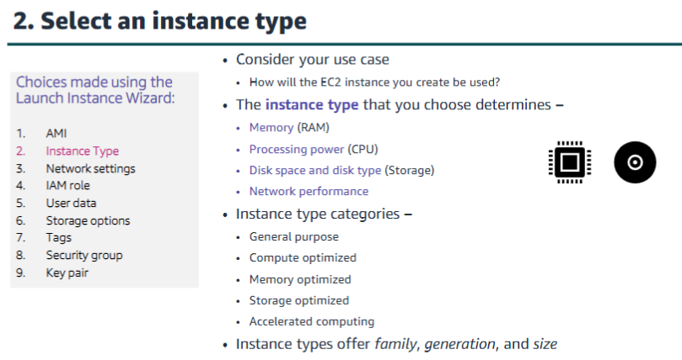

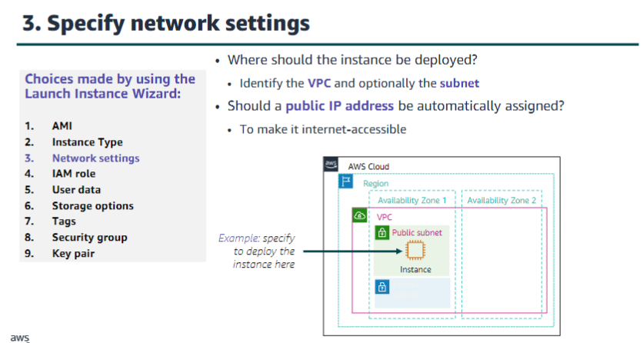

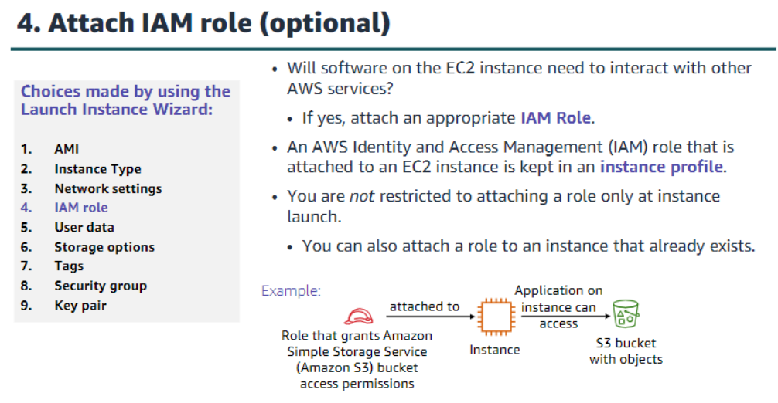

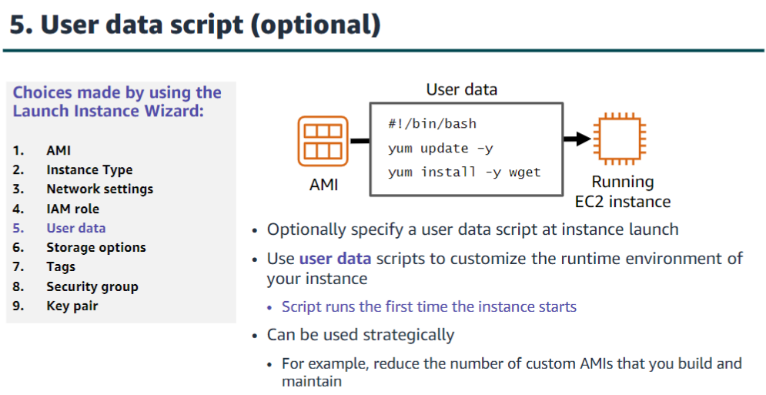

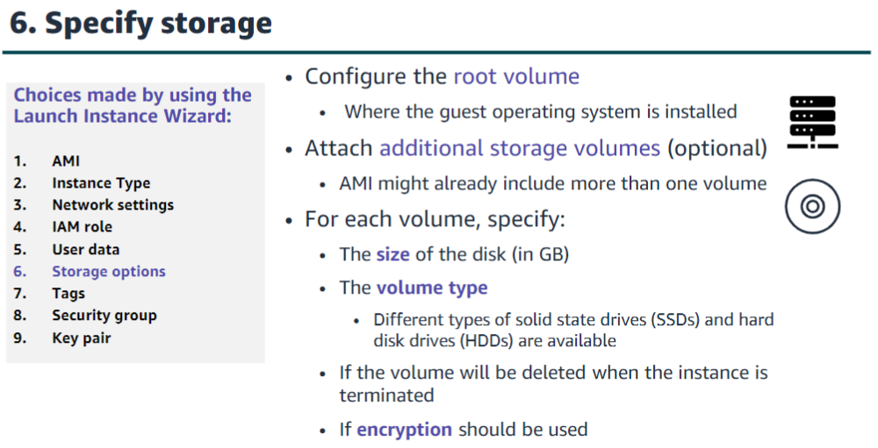

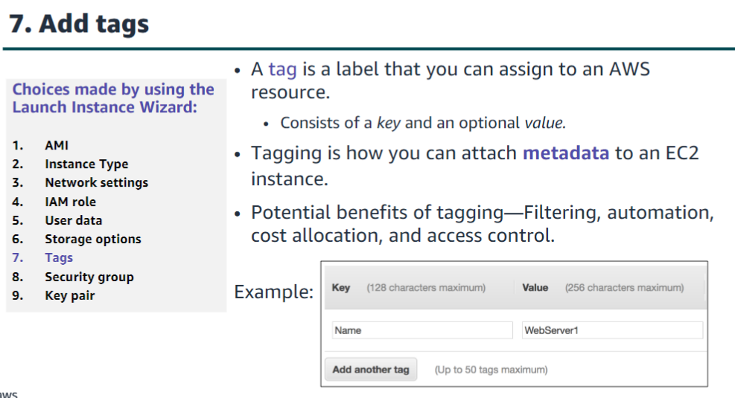

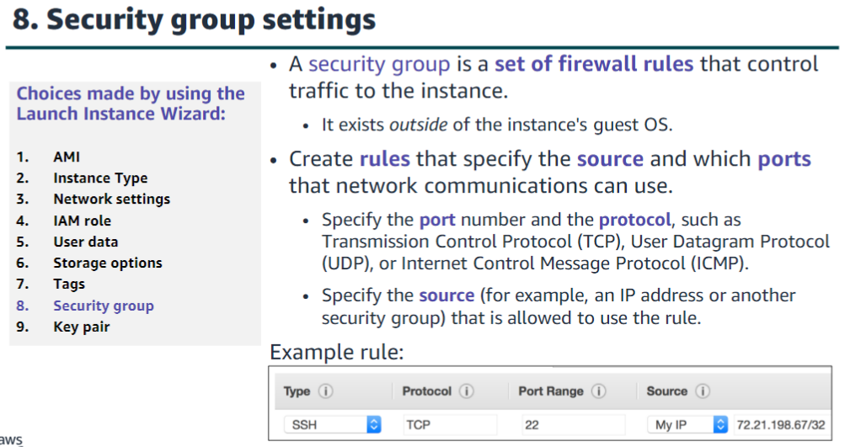

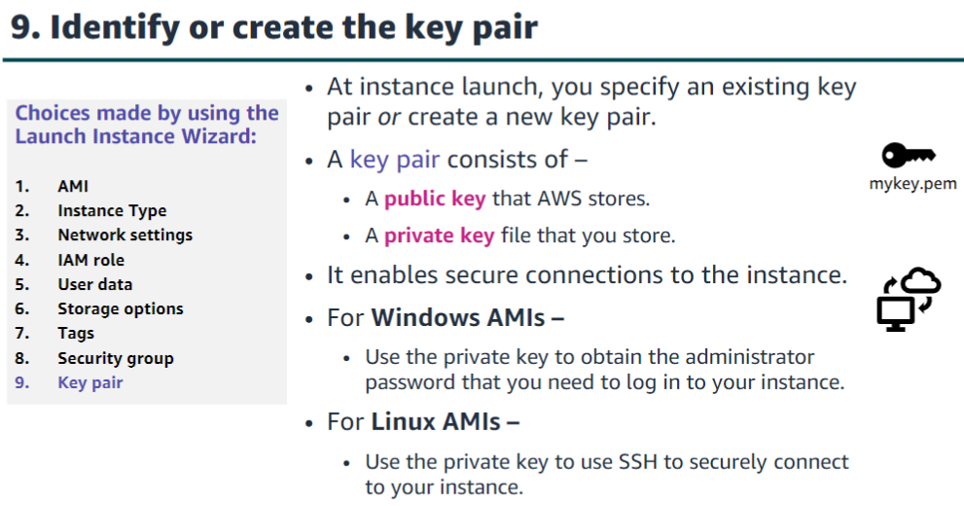

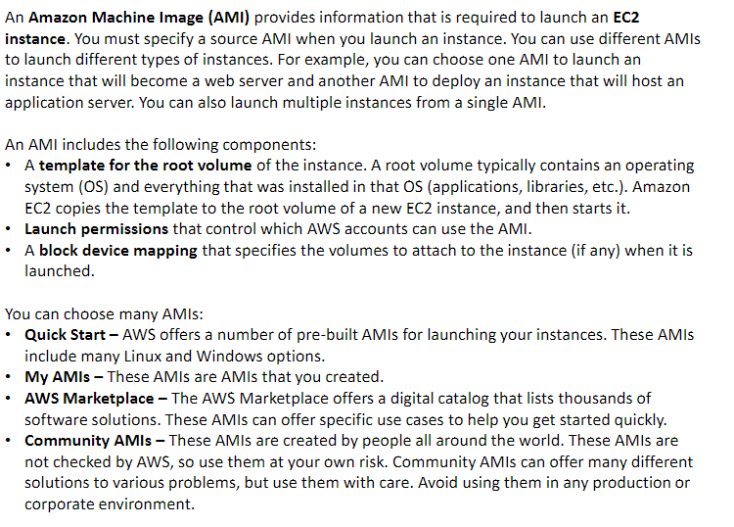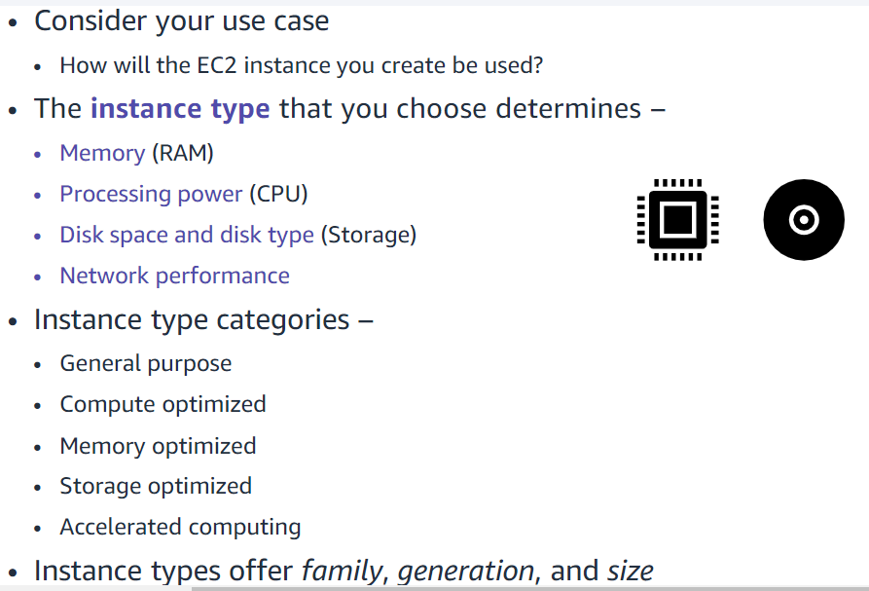

When you look at an EC2 instance type, you will see that its name has several parts. For example, consider the T type.   
T is the family name, which is then followed by a number.   
Here, that number is 3. The number is the generation number of that type. So, a t3 instance is the third generation of the T family. In general, instance types that are of a higher generation are more powerful and provide a better value for the price.  
The next part of the name is the size portion of the instance. When you compare sizes, it is important to look at the coefficient portion of the size category. For example, a t3.2xlarge has twice the vCPU and memory of a t3.xlarge.   
The t3.xlarge has, in turn, twice the vCPU and memory of a t3.large.  
It is also important to note that network bandwidth is also tied to the size of the Amazon EC2 instance. If you will run jobs that will be very network-intensive, you might be required to increase the instance specifications to meet your needs.

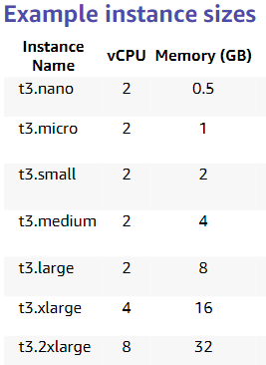

When you launch multiple new EC2 instances, Amazon EC2 attempts to place the instances so that they are spread out across the underlying hardware by default. It does this to minimize correlated failures. However, if you want to specify specific placement criteria, you can use placement groups to influence the placement of a group of interdependent instances to meet the needs of your workload. For example, you might specify that three instances should all be deployed in the same Availability Zone to ensure lower network latency and higher network throughput between instances.

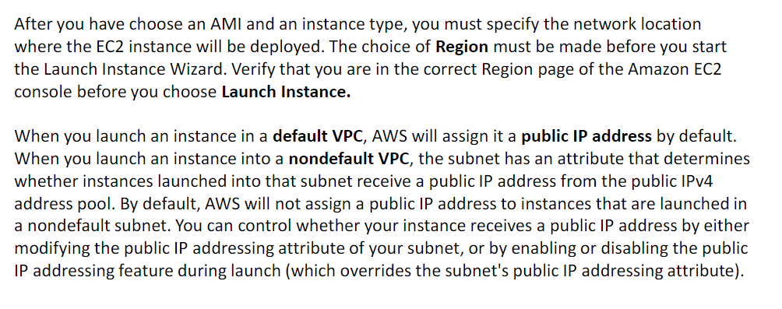

It is common to use EC2 instances to run an application that must make secure API calls to other AWS services. To support these use cases, AWS enables you to attach an AWS Identity and Access Management (IAM) role to an EC2 instance. Without this feature, you might be tempted to place AWS credentials on an EC2 instance so an application that runs on that instance to use. However, you should never store AWS credentials on an EC2 instance. It is highly insecure. Instead, attach an IAM role to the EC2 instance.

The IAM role then grants permission to make application programming interface (API) requests to the applications that run on the EC2 instance.

An instance profile is a container for an IAM role. If you use the AWS Management Console to create a role for Amazon EC2, the console automatically creates an instance profile and gives it the same name as the role. When you then use the Amazon EC2 console to launch an instance with an IAM role, you can select a role to associate with the instance. In the console, the list that displays is actually a list of instance profile names.

When you create your EC2 instances, you have the option of passing user data to the instance. User data can automate the completion of installations and configurations at instance launch. For example, a user data script might patch and update the instance's operating system, fetch and install software license keys, or install additional software.

When the EC2 instance is created, the user data script will run with root privileges during the final phases of the boot process. On Linux instances, it is run by the cloud-init service. On Windows instances, it is run by the EC2Configor EC2Launchutility. By default, user data only runs the first time that the instance starts up. However, if you would like your user data script to run every time the instance is booted, you can create a Multipurpose Internet Mail Extensions (MIME) multipart file user data script (this process is not commonly done).

When you launch an EC2 instance, you can configure storage options. For example, you can configure the size of the root volume where the guest operating system is installed. You can also attach additional storage volumes when you launch the instance. Some AMIs are also configured to launch more than one storage volume by default to provide storage that is separate from the root volume. For each volume that your instance will have, you can specify the size of the disks, the volume types, and whether the storage will be retained if the instance is terminated. You can also specify if encryption should be used.

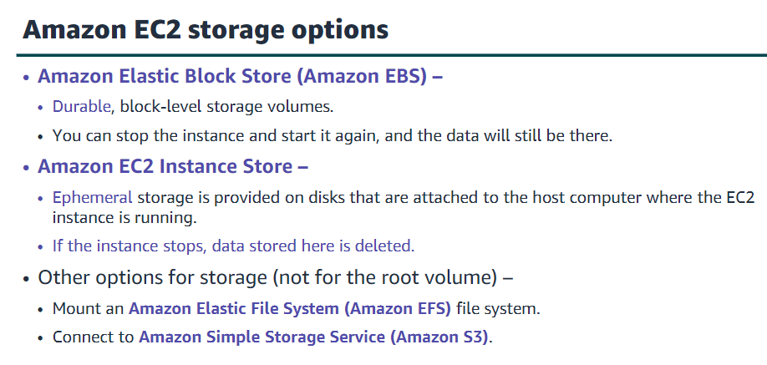

A tag is a label that you assign to an AWS resource. Each tag consists of a key and an optional value, both of which you define. Tags enable you to categorize AWS resources, such as EC2 instances, in different ways. For example, you might tag instances by purpose, owner, or environment.

Tagging is how you can attach metadata to an EC2 instance. Tag keys and tag values are case-sensitive. For example, a commonly used tag for EC2 instances is a tag key that is called Name and a tag value that describes the instance, such as My Web Server.

The Name tag is exposed by default in the Amazon EC2 console Instances page. However, if you create a key that is called name (with lower-case n), it will not appear in the Name column for the list of instances (though it will still appear in the instance details panel in the Tags tab). It is a best practice to develop tagging strategies. Using a consistent set of tag keys makes it easier for you to manage your resources.

A security group acts as a virtual firewall that controls network traffic for one or more instances. When you launch an instance, you can specify one or more security groups; otherwise, the default security group is used. You can add rules to each security group. Rules allow traffic to or from its associated instances. You can modify the rules for a security group at any time, and the new rules will be automatically applied to all instances that are associated with the security group. When AWS decides whether to allow traffic to reach an instance, all the rules from all the security groups that are associated with the instance are evaluated.

When you launch an instance in a virtual private cloud (VPC), you must either create a new security group or use one that already exists in that VPC. After you launch an instance, you can change its security groups. When you define a rule, you can specify the allowable source of the network communication (inbound rules) or destination (outbound rules). The source can be an IP address, an IP address range, another security group, a gateway VPC endpoint, or anywhere (which means that all sources will be allowed).

By default, a security group includes an outbound rule that allows all outbound traffic. You can remove the rule and add outbound rules that only allow specific outbound traffic. If your security group has no outbound rules, no outbound traffic that originates from your instance is allowed.

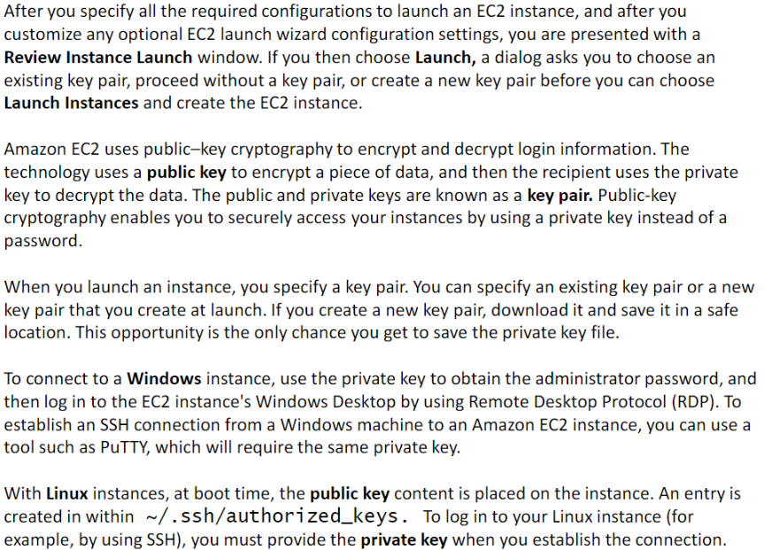

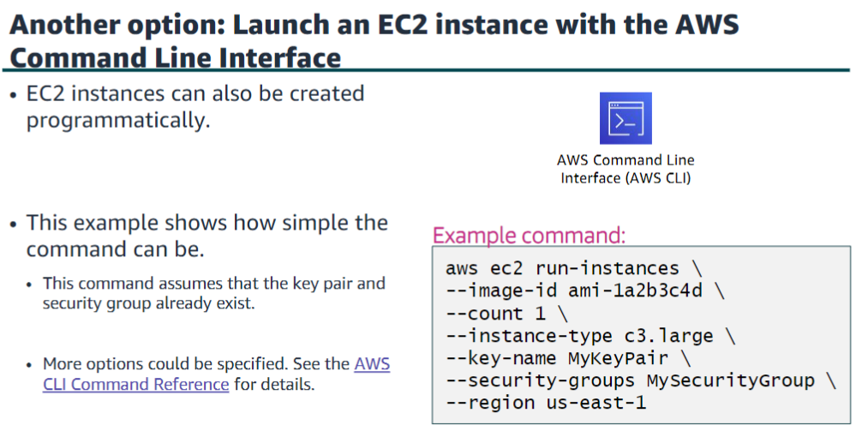

An instance can be in one of the following states:

•Pending–When an instance is first launched from an AMI, or when you start a stopped instance, it enters the pending state when the instance is booted and deployed to a host computer. The instance type that you specified at launch determines the hardware of the host computer for your instance.

•Running–When the instance is fully booted and ready, it exits the pending state and enters the running state. You can connect over the internet to your running instance.

•Rebooting –AWS recommends you reboot an instance by using the Amazon EC2 console, AWS CLI, or AWS SDKs instead of invoking a reboot from within the guest operating system (OS). A rebooted instance stays on the same physical host, maintains the same public DNS name and public IP address, and if it has instance store volumes, it retains the data on those volumes.

•Shutting down –This state is an intermediary state between running and terminated.

•Terminated–A terminated instance remains visible in the Amazon EC2 console for a while before the virtual machine is deleted. However, you can’t connect to or recover a terminated instance.

•Stopping–Instances that are backed by Amazon EBS can be stopped. They enter the stopping state before they attain the fully stopped state.

•Stopped–A stopped instance will not incur the same cost as a running instance. Starting a stopped instance puts it back into the pending state, which moves the instance to a new host machine.

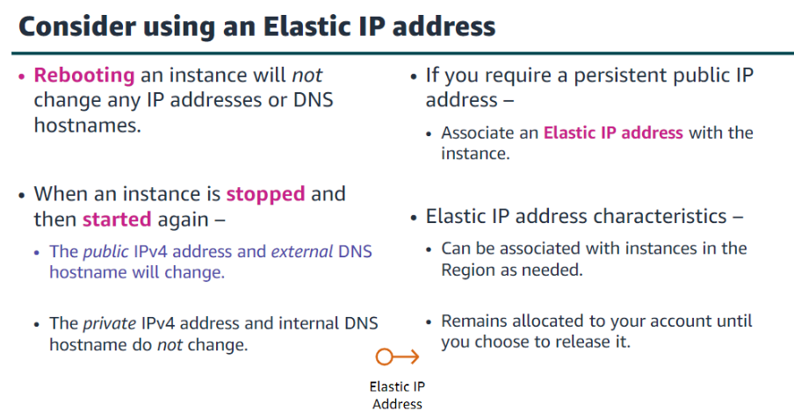

You can monitor your instances by using Amazon CloudWatch, which collects and processes raw data from Amazon EC2 into readable, near-real-time metrics. These statistics are recorded for a period of 15 months, so you can access historical information and gain a better perspective on how your web application or service is performing. By default, Amazon EC2 provides basic monitoring, which sends metric data to CloudWatch in 5-minute periods. To send metric data for your instance to CloudWatch in 1-minute periods, you can enable detailed monitoring on the instance.

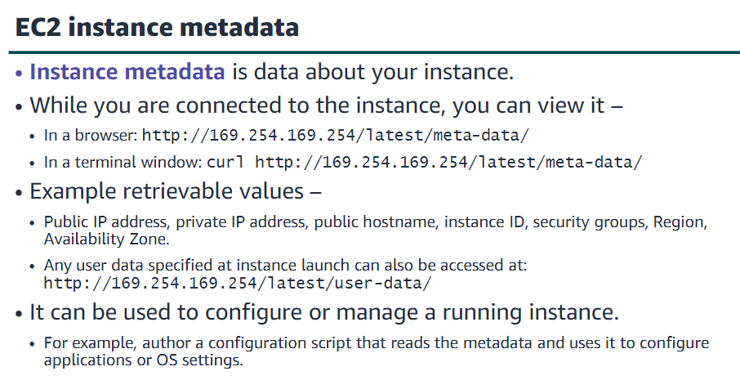

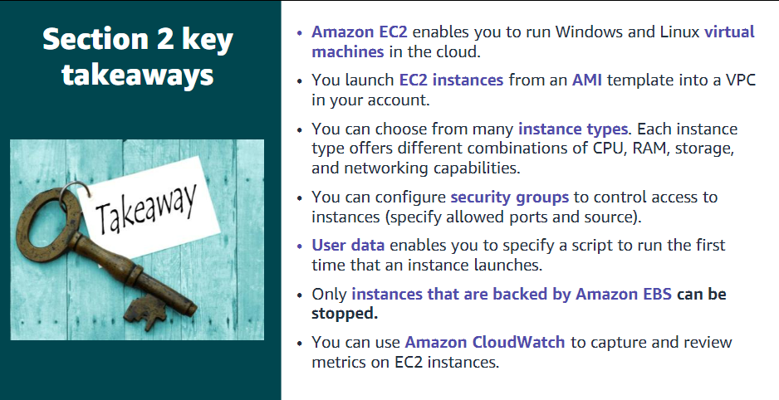

Section 3: Amazon EC2 cost optimization

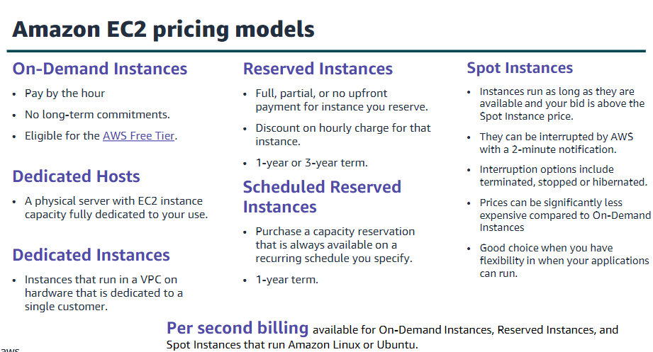

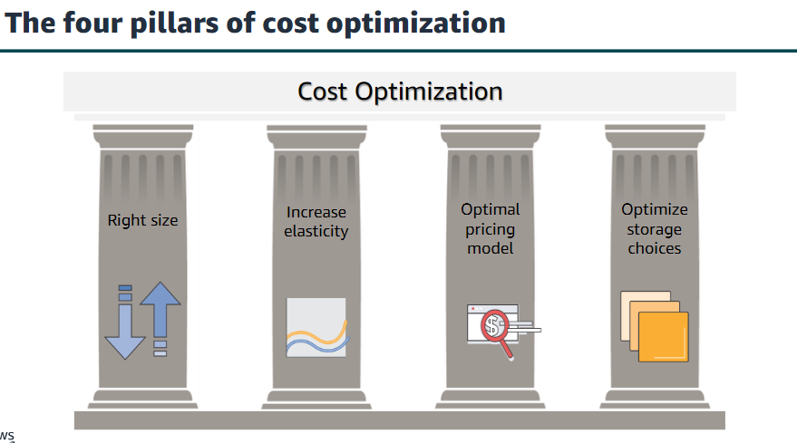

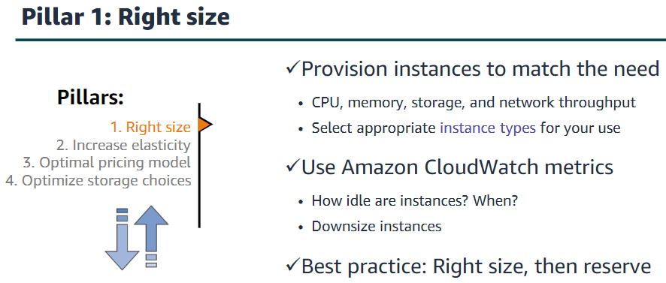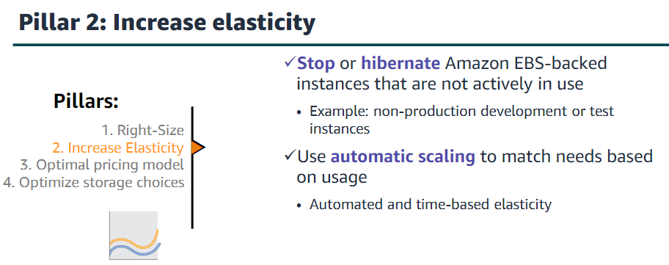

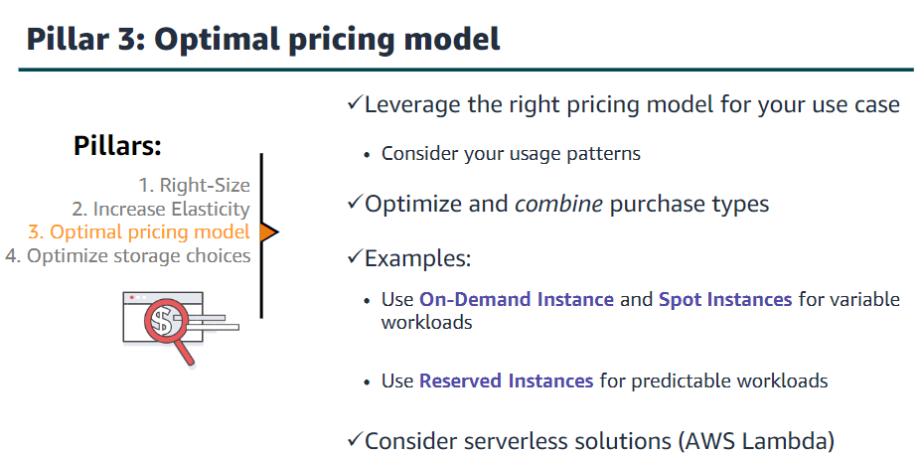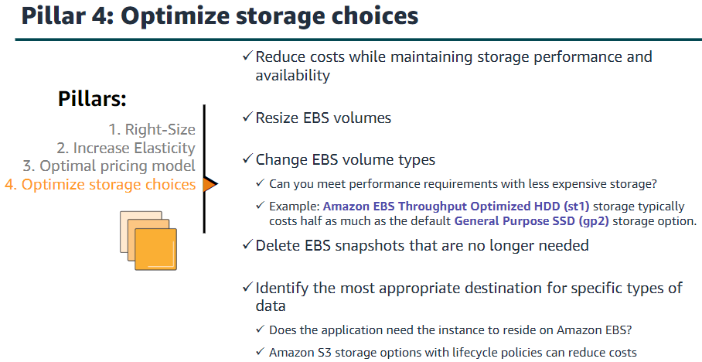

Section 4: Container services

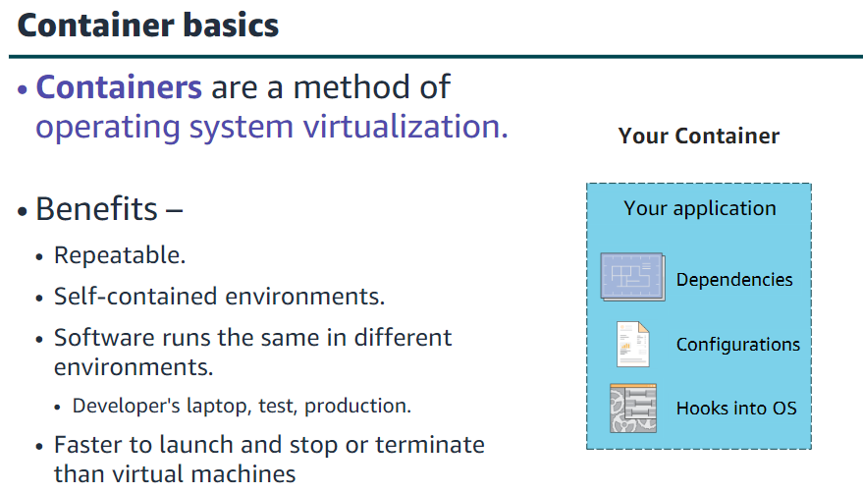

• Docker is a software platform that enables you to build, test, and deploy applications quickly.  
•You run containers on Docker.  
•Containers are created from a template called an image.  
•A container has everything a software application needs to run.

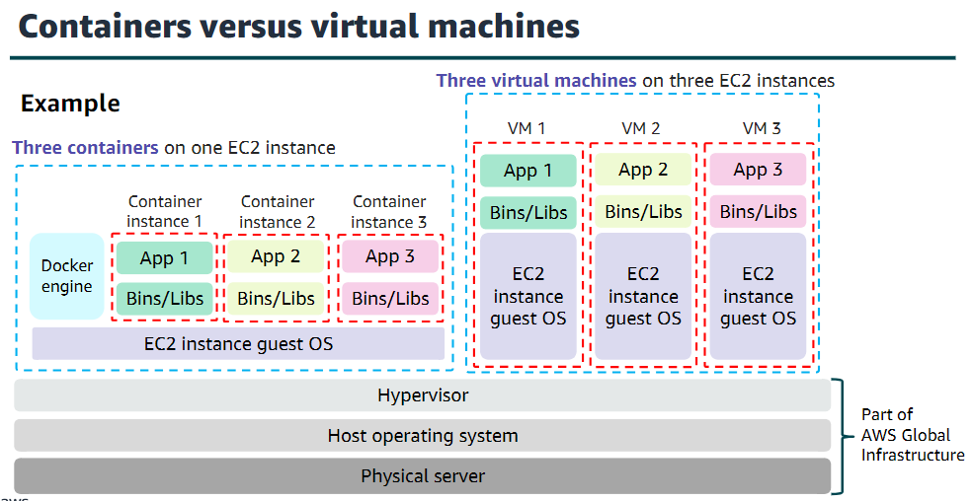

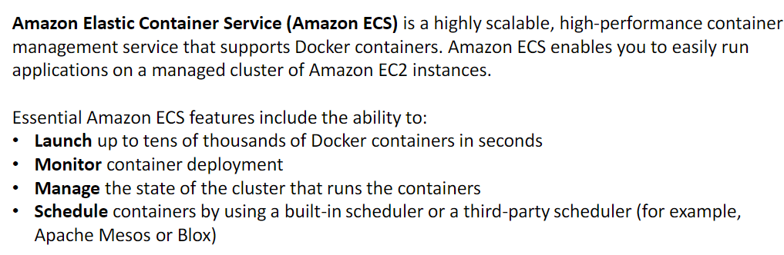

To prepare your application to run on Amazon ECS, you create a task definition which is a text file that describes one or more containers, up to a maximum of ten, that form your application.  
A task is the instantiation of a task definition within a cluster. You can specify the number of tasks that will run on your cluster. The Amazon ECS task scheduler is responsible for placing tasks within your cluster.

When Amazon ECS runs the containers that make up your task, it places them on an ECS cluster. The cluster (when you choose the EC2 launch type) consists of a group of EC2 instances each of which is running an Amazon ECS container agent.

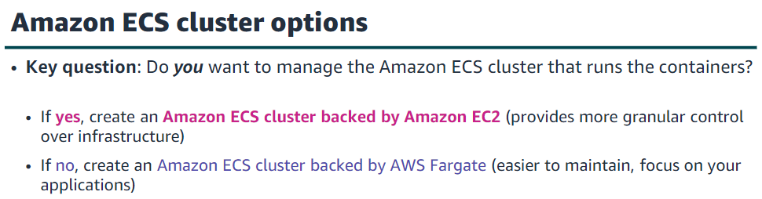

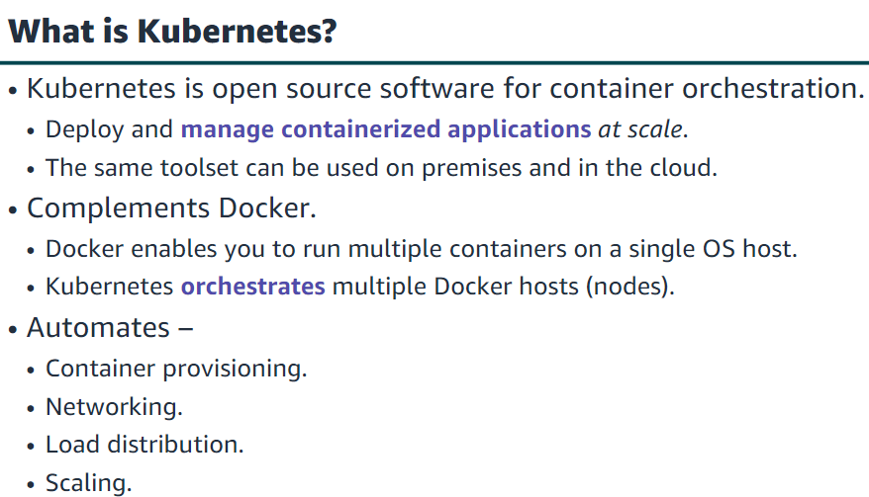

Amazon Elastic Container Registry (Amazon ECR) is a fully managed Docker container registry that makes it easy for developers to store, manage, and deploy Docker container images. It is integrated with Amazon ECS, so you can store, run, and manage container images for applications that run on Amazon ECS. Specify the Amazon ECR repository in your task definition, and Amazon ECS will retrieve the appropriate images for your applications.

Amazon ECR supports Docker Registry HTTP API version 2, which enables you to interact with Amazon ECR by using Docker CLI commands or your preferred Docker tools. Thus, you can maintain your existing development workflow and access Amazon ECR from any Docker environment—whether it is in the cloud, on-premises, or on your local machine.

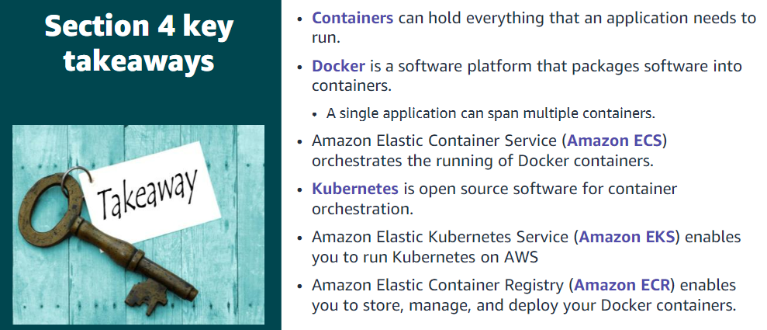

Section 5: Introduction to AWS Lambda

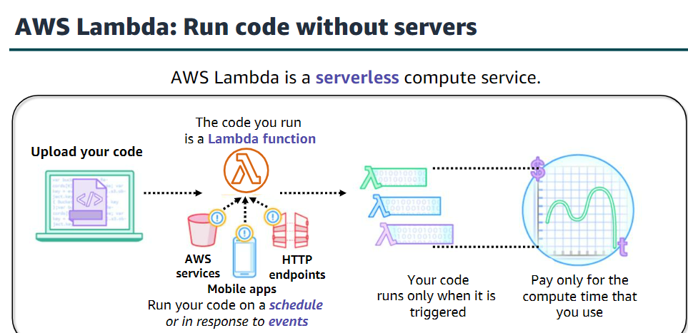

AWS offers many compute options. For example, Amazon EC2 provides virtual machines. As another example, Amazon ECS and Amazon EKS are container-based compute services. However, there is another approach to compute that does not require you to provision or manage servers. This third approach is often referred to as serverless computing  
AWS Lambda is an event-driven, serverless compute service. Lambda enables you to run code without provisioning or managing servers.

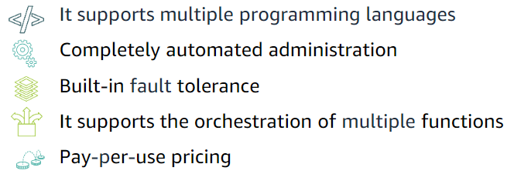

An event source is an AWS service or a developer-created application that produces events that trigger an AWS Lambda function to run. Lambda can pull records from an Amazon Simple Queue Service (Amazon SQS) queue and run a Lambda function for each fetched message. Lambda can similarly read events from Amazon DynamoDB. Some services, such as Elastic Load Balancing (Application Load Balancer) and Amazon API Gateway can invoke your Lambda function directly.

You can invoke Lambda functions directly with the Lambda console, the Lambda API, the AWS software development kit (SDK), the AWS CLI, and AWS toolkits.

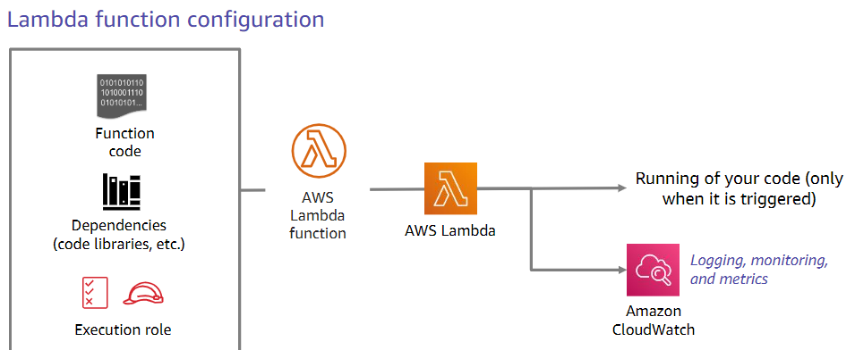

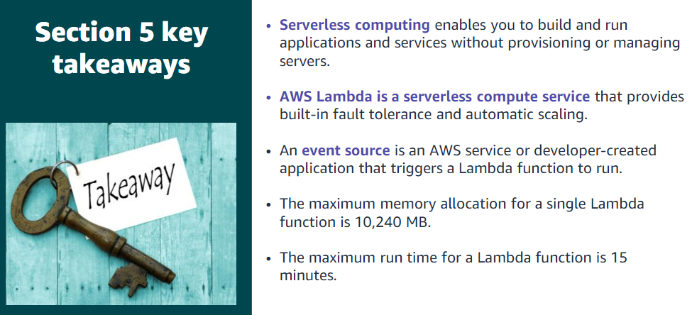

Section 6: Introduction to AWS Elastic Beanstalk

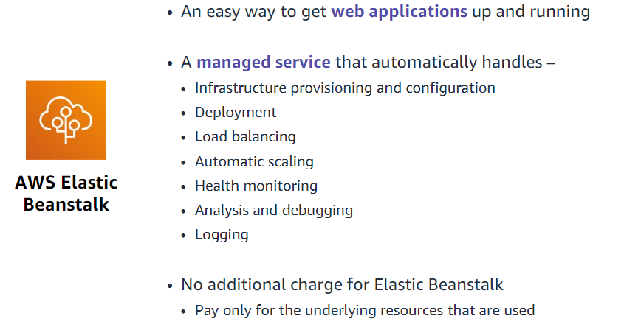

AWS Elastic Beanstalk deploys your code on Apache Tomcat for Java applications; Apache HTTP Server for PHP and Python applications; NGINX or Apache HTTP Server for Node.js applications; Passenger or Puma for Ruby applications; and Microsoft Internet Information Services (IIS) for .NET applications, Java SE, Docker, and Go.

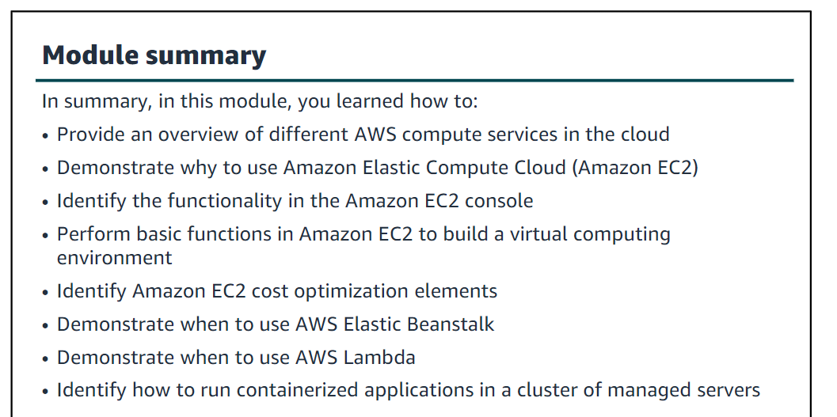

Module 7: Storage

This module addresses the following topics:

•Amazon Elastic Block Store (Amazon EBS)  
•Amazon Simple Storage Service (Amazon S3)  
•Amazon Elastic File System (Amazon EFS)  
•Amazon Simple Storage Service Glacier

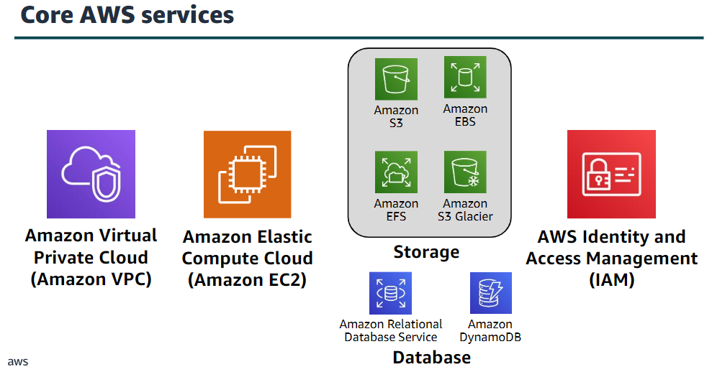

Section 1: Amazon Elastic Block Store (Amazon EBS)

Amazon EBS provides persistent block storage volumes for use with Amazon EC2 instances. Persistent storage is any data storage device that retains data after power to that device is shut off.

It is also sometimes called non-volatile storage. Each Amazon EBS volume is automatically replicated within its Availability Zone to protect you from component failure. It is designed for high availability and durability.

Amazon EBS volumes provide the consistent and low-latency performance that is needed to run your workloads. With Amazon EBS, you can scale your usage up or down within minutes, while paying a low price for only what you provision.

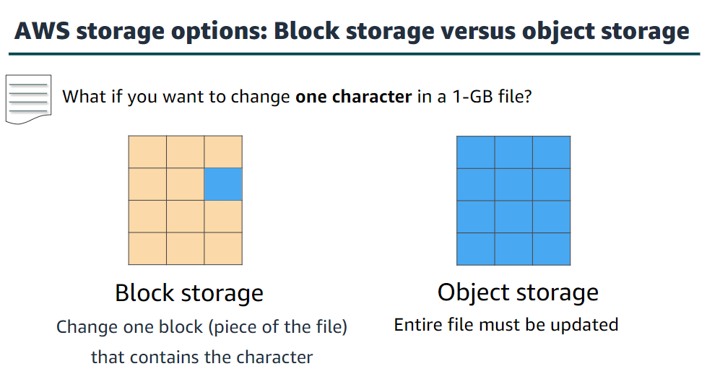

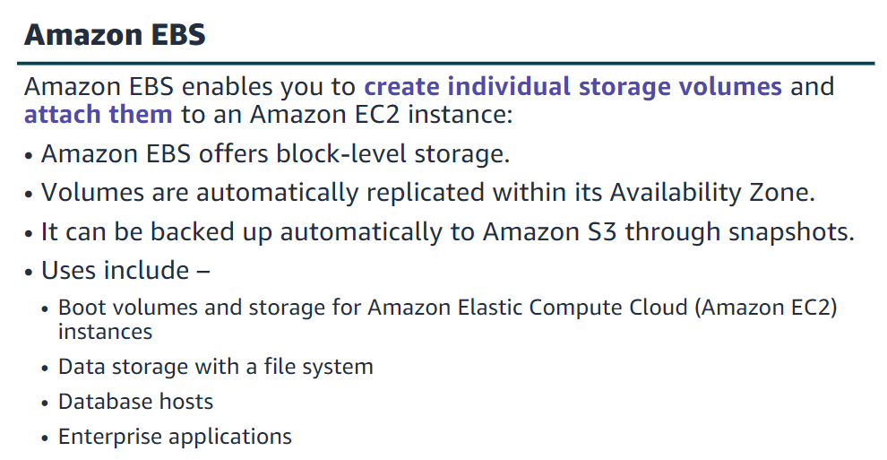

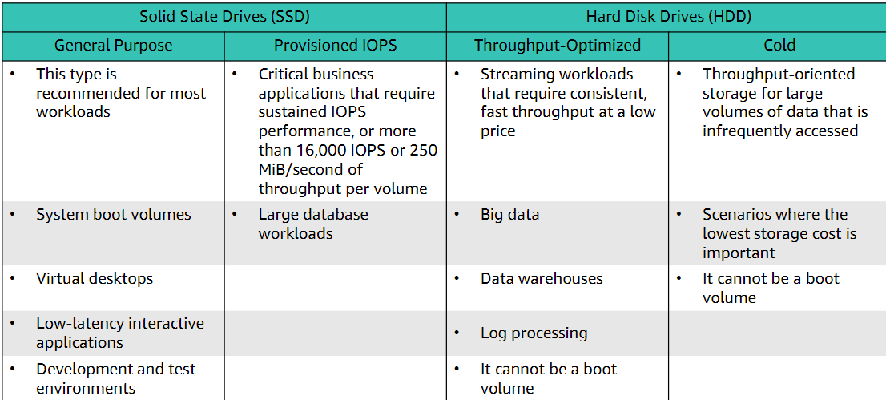

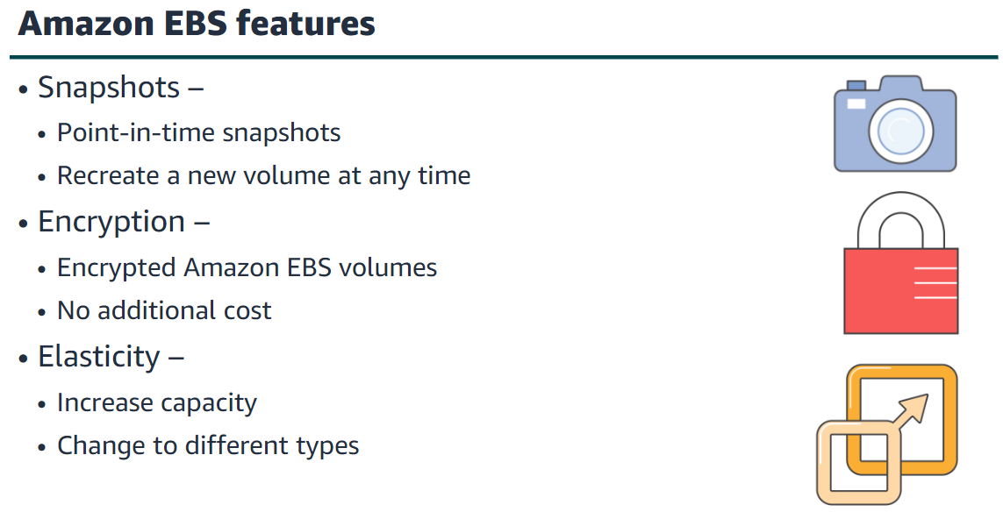

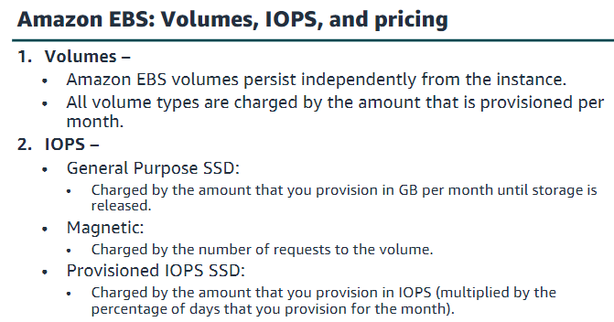

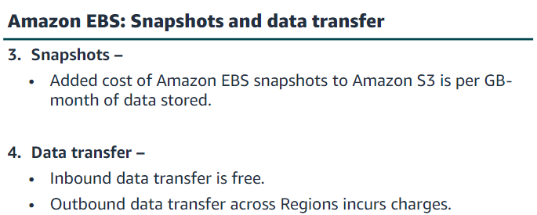

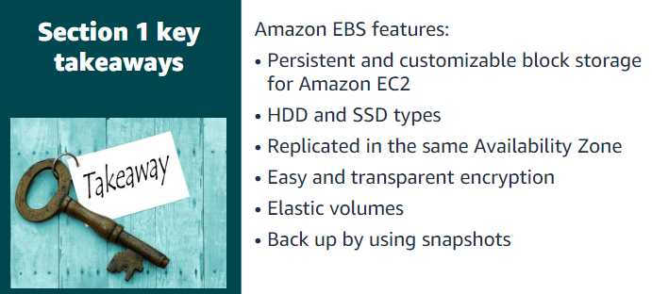

Section 2: Amazon Simple Storage Service (Amazon S3)

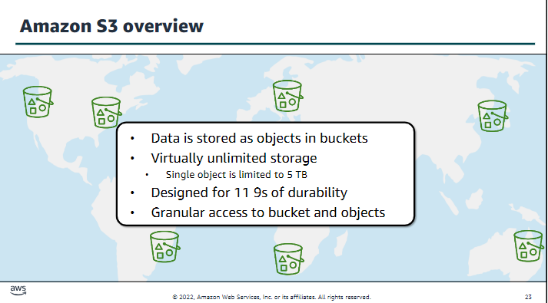

Amazon S3 offers a range of object-level storage classes that are designed for different use cases.

These classes include:

•Amazon S3 Standard –Amazon S3 Standard is designed for high durability, availability, and performance object storage for frequently accessed data. Because it delivers low latency and high throughput, Amazon S3 Standard is appropriate for a variety of use cases, including cloud applications, dynamic websites, content distribution, mobile and gaming applications, and big data analytics.

•Amazon S3 Intelligent-Tiering–The Amazon S3 Intelligent-Tiering storage class is designed to optimize costs by automatically moving data to the most cost-effective access tier, without performance impact or operational overhead. For a small monthly monitoring and automation fee per object, Amazon S3 monitors access patterns of the objects in Amazon S3 Intelligent-Tiering, and moves the objects that have not been accessed for 30 consecutive days to the infrequent access tier. If an object in the infrequent access tier is accessed, it is automatically moved back to the frequent access tier.

•Amazon S3 Standard-Infrequent Access (Amazon S3 Standard-IA) –The Amazon S3 Standard-IA storage class is used for data that is accessed less frequently, but requires rapid access when needed. Amazon S3 Standard-IA is designed to provide the high durability, high throughput, and low latency of Amazon S3 Standard, with a low per-GB storage price and per-GB retrieval fee.

•Amazon S3 Glacier –Amazon S3 Glacier is a secure, durable, and low-cost storage class for data archiving. You can reliably store any amount of data at costs that are competitive with—or cheaper than—on-premises solutions. To keep costs low yet suitable for varying needs, Amazon S3 Glacier provides three retrieval options that range from a few minutes to hours.

•Amazon S3 Glacier Deep Archive –Amazon S3 Glacier Deep Archive is the lowest-cost storage class for Amazon S3. It supports long-term retention and digital preservation for data that might be accessed once or twice in a year. It is designed for customers—particularly customers in highly regulated industries, such as financial services, healthcare, and public sectors—that retain datasets for 7–10 years (or more) to meet regulatory compliance requirements.

Section 3: Amazon Elastic File

System (Amazon EFS)

Amazon Elastic File System (Amazon EFS) provides simple, scalable, elastic file storage for use with AWS services and on-premises resources. It offers a simple interface that enables you to create and configure file systems quickly and easily. Amazon EFS is built to dynamically scale on demand without disrupting applications—it will grow and shrink automatically as you add and remove files. It is designed so that your applications have the storage they need, when they need it.

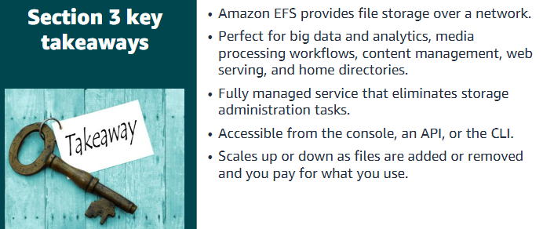

Section 4: Amazon S3 Glacier

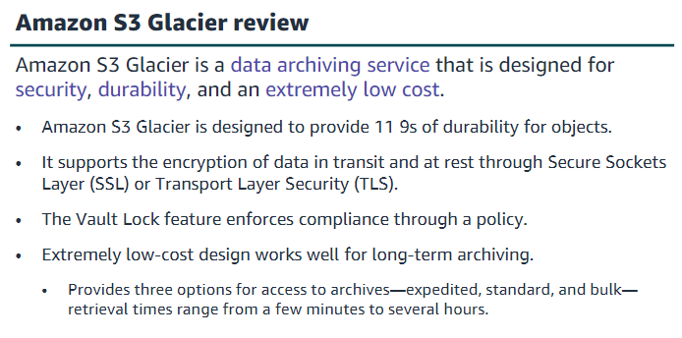

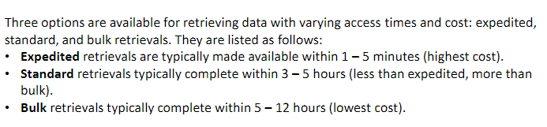

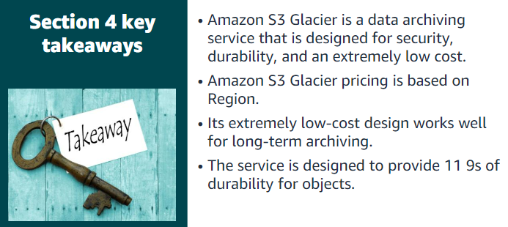

Module 8: Databases

This module will address the following topics:

•Amazon Relational Database Service (Amazon RDS)

•Amazon DynamoDB

•Amazon Redshift

•Amazon Aurora

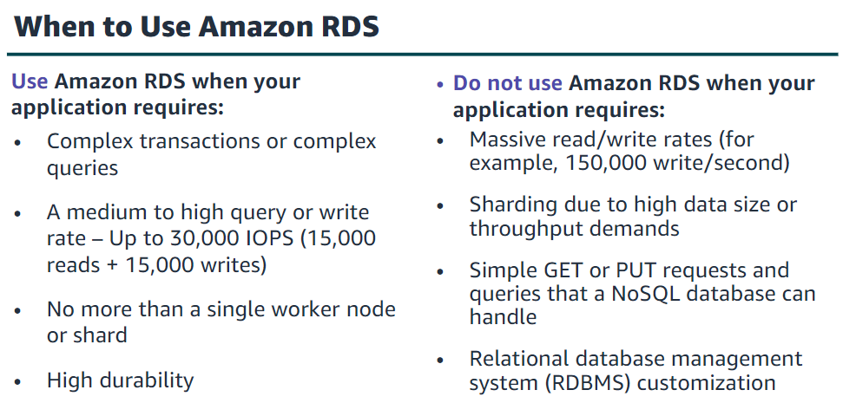

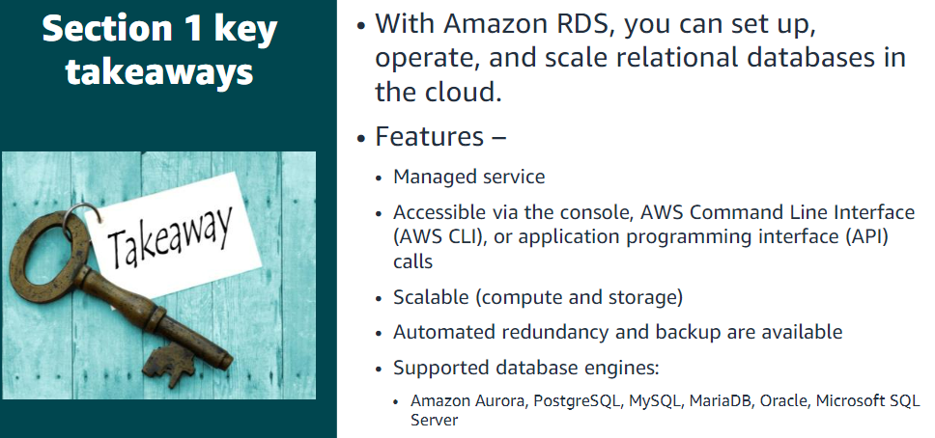

Section 2: Amazon DynamoDB

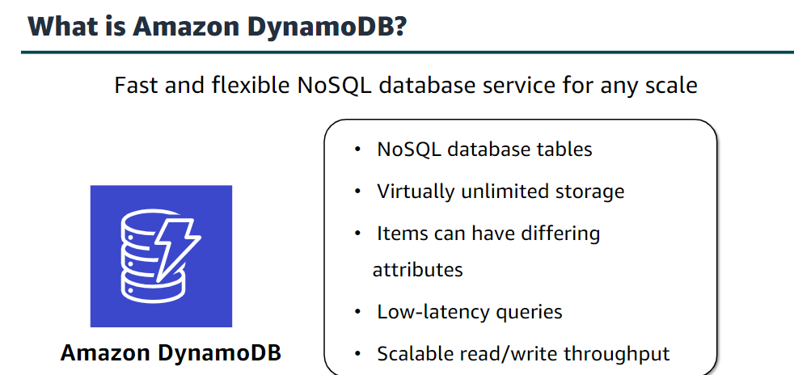

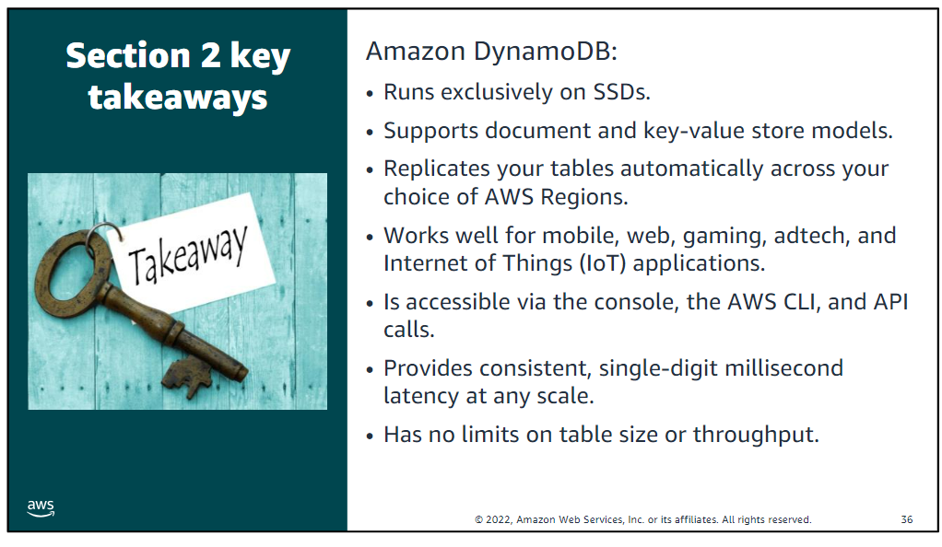

Section 3: Amazon Redshift

Amazon Redshift is a fast, fully managed data warehouse that makes it simple and cost-effective to analyze all your data by using standard SQL and your existing business intelligence (BI) tools.

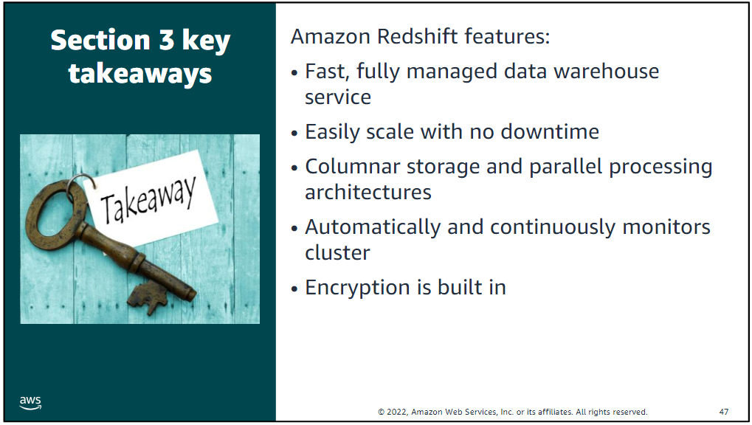

Section 4: Amazon Aurora

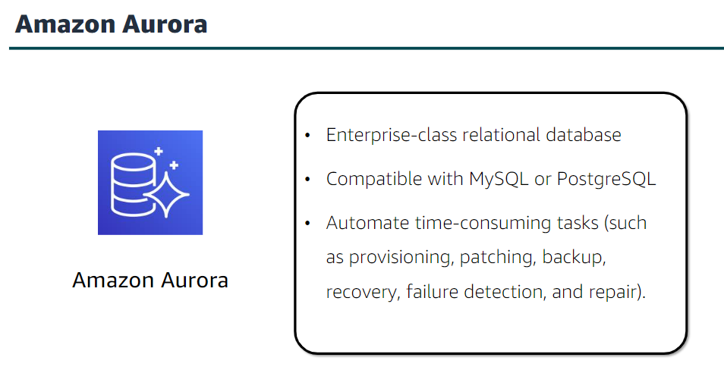

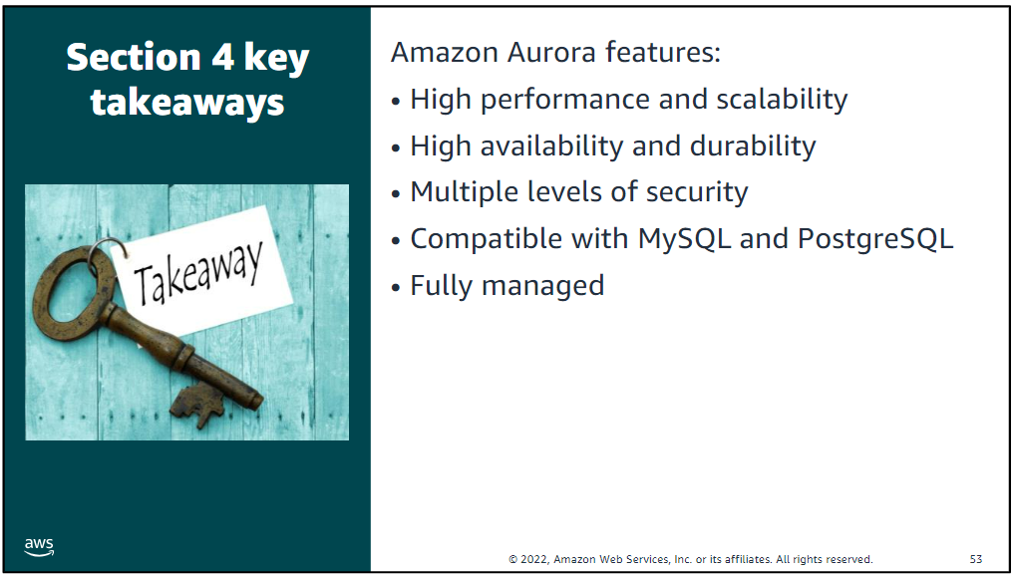

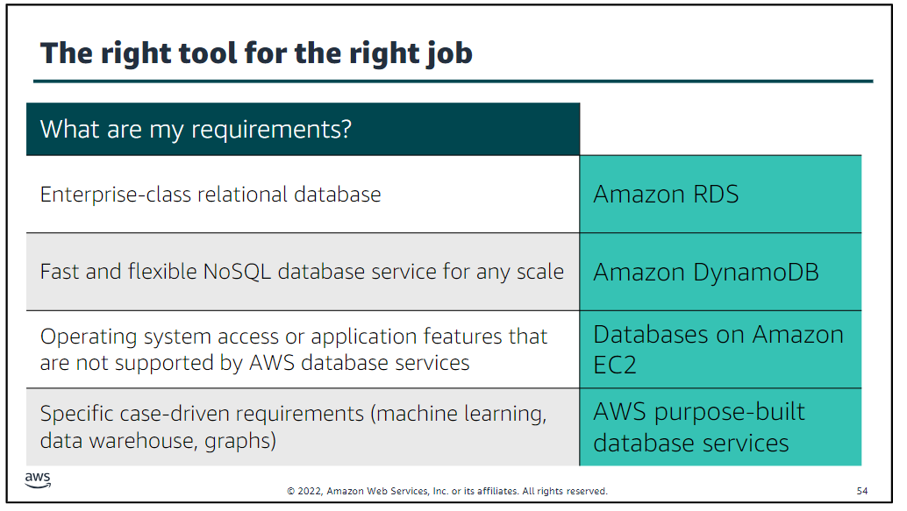

Module 9: Cloud Architecture

Section 1: AWS Well-Architected Framework

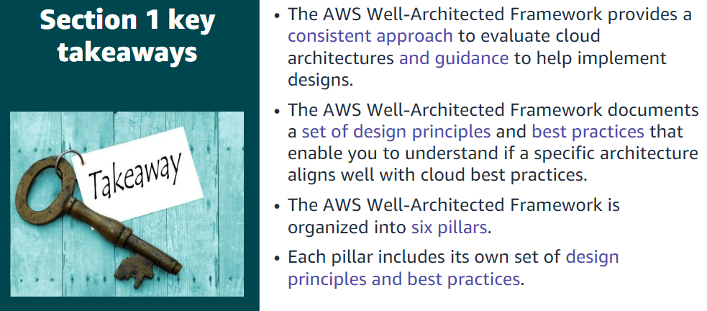

Section 2: Reliability and availability

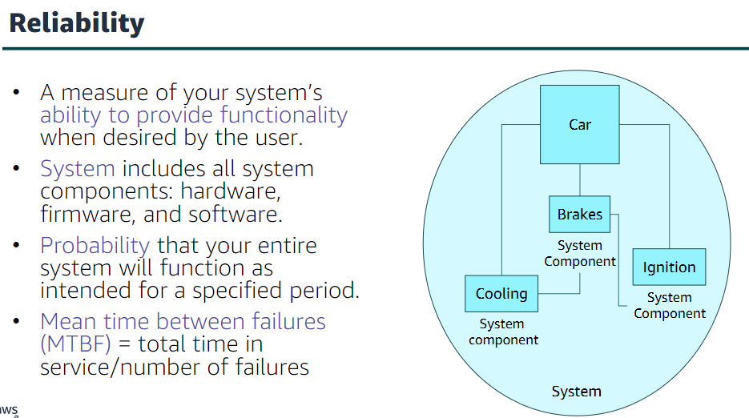

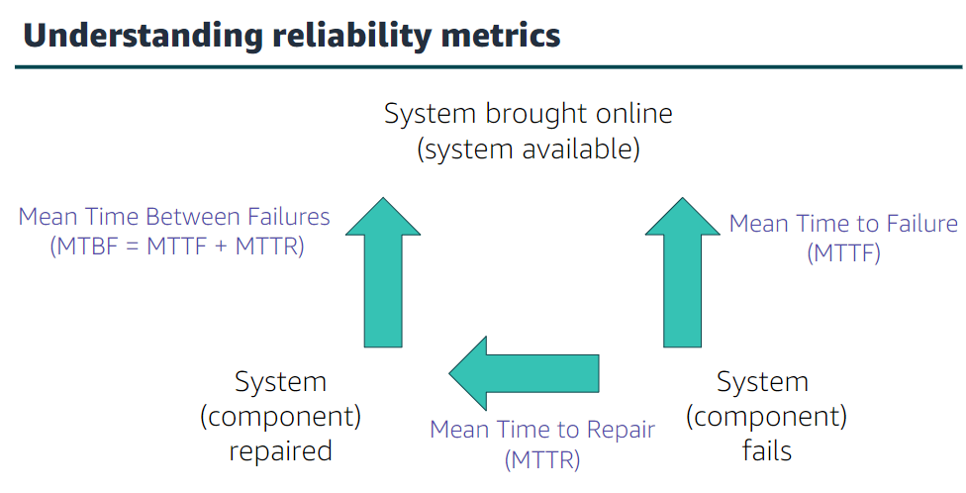

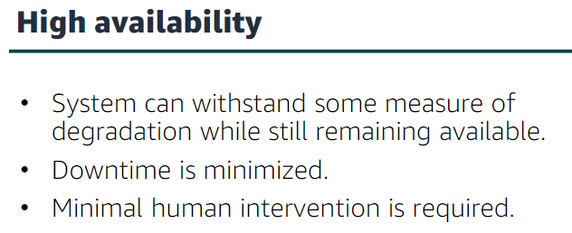

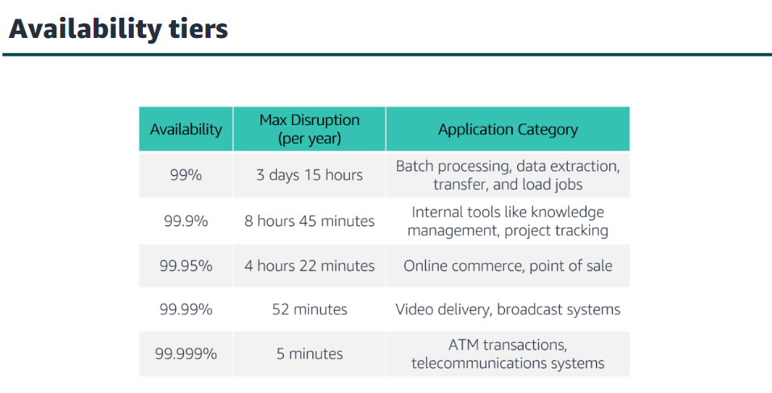

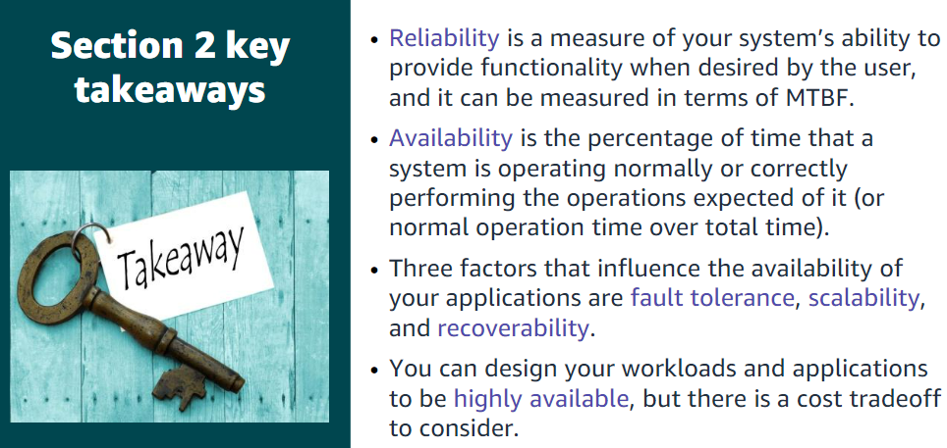

Section 3: AWS Trusted Advisor

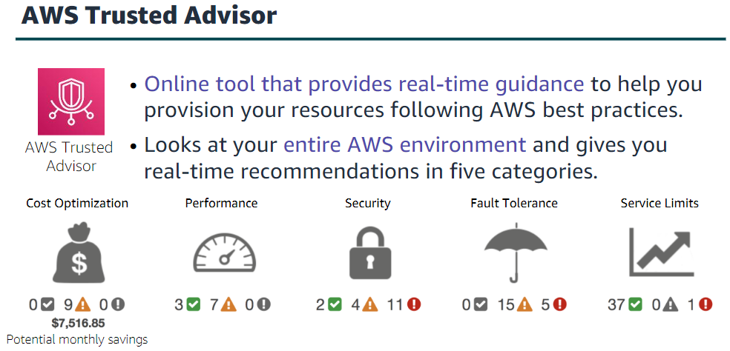

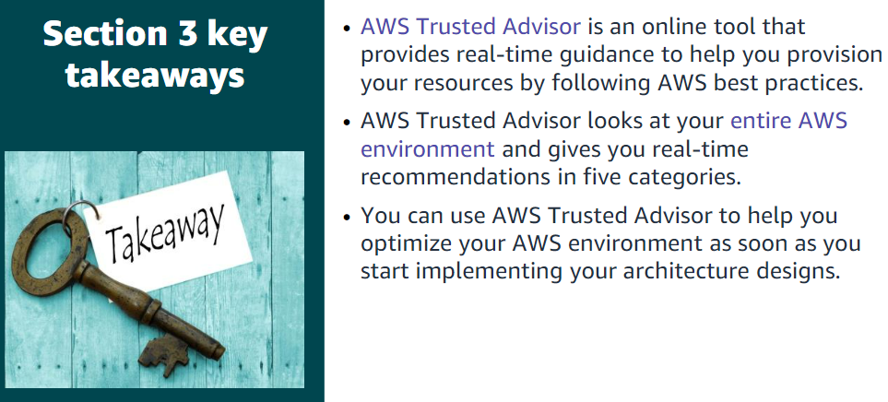

Module 10: Automatic Scaling and Monitoring

Section 1: Elastic Load Balancing

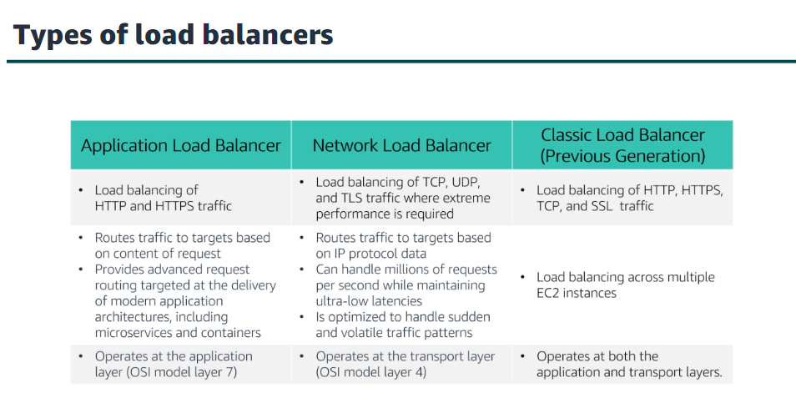

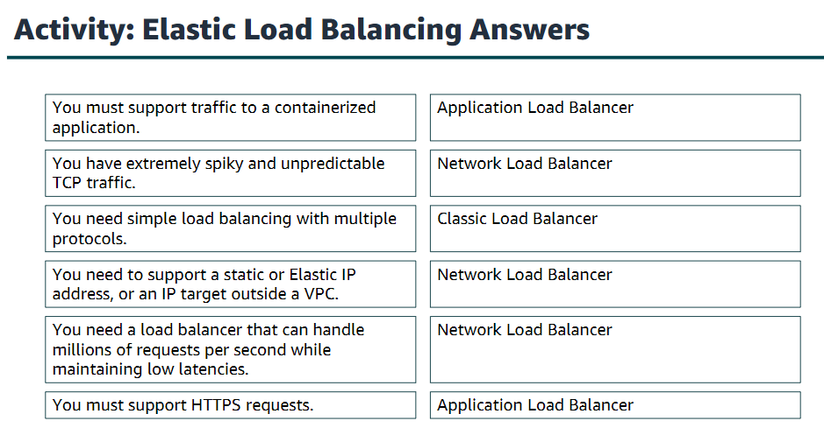

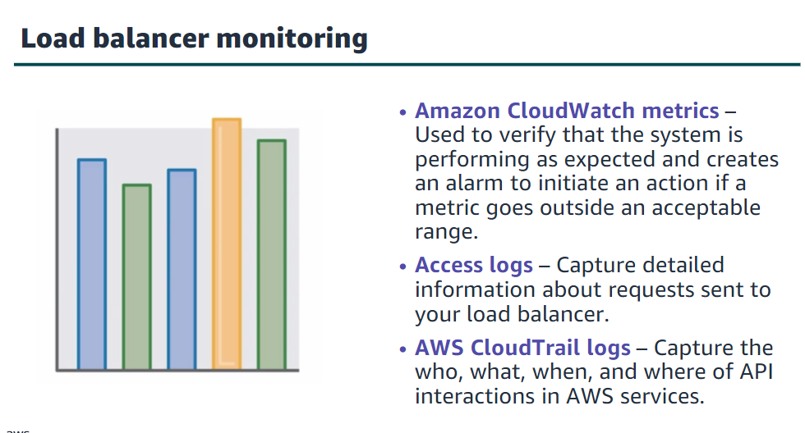

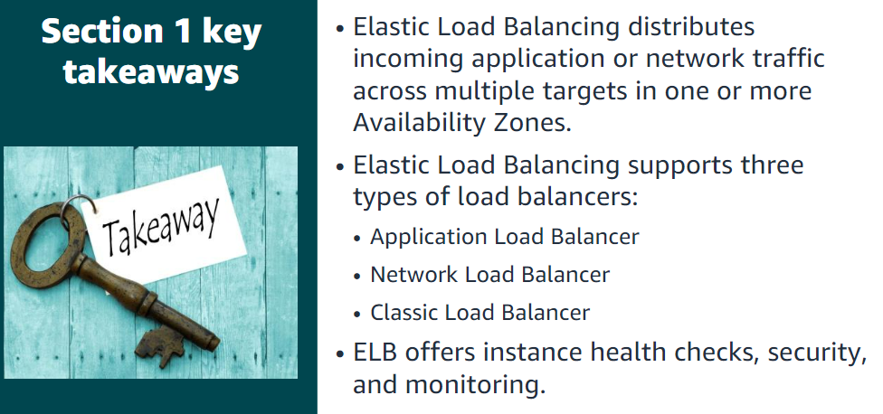

Section 2: Amazon CloudWatch

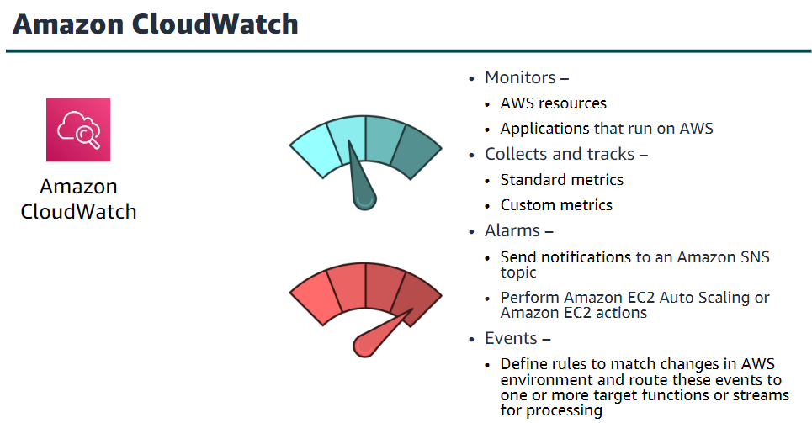

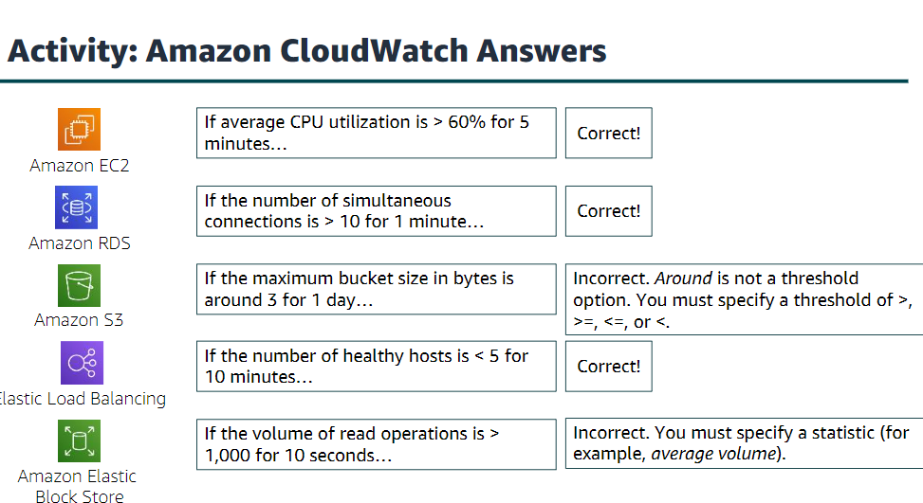

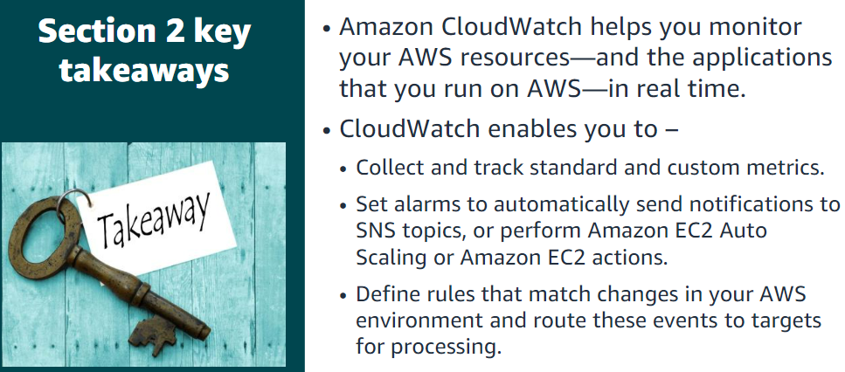

Section 3: Amazon EC2 Auto Scaling

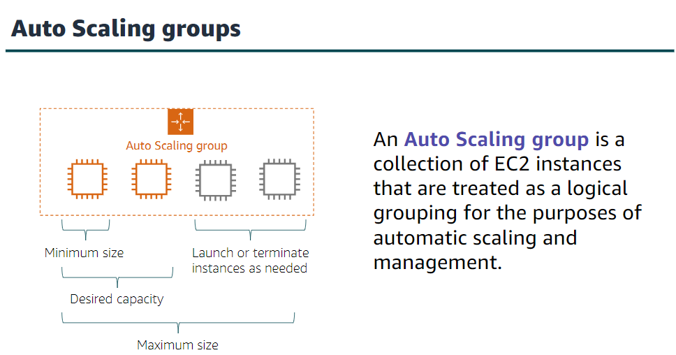

With Amazon EC2 Auto Scaling, launching instances is referred to as scaling out, and terminating instances is referred to as scaling in.

